VISVESVARAYA TECHNOLOGICAL UNIVERSITY

“JnanaSangama”, Belgaum -590014, Karnataka.



# LAB REPORT

**On**

# DATA STRUCTURES (23CS3PCDST)

Submitted by

# Supreeth AR(2023BMS02528)

in partial fulfillment for the award of the degree of BACHELOR OF ENGINEERING

in

COMPUTER SCIENCE AND ENGINEERING



# B.M.S. COLLEGE OF ENGINEERING (Autonomous Institution under VTU)

**BENGALURU-560019**

# Dec 2023- March 2024

**B. M. S. College of Engineering,**

**Bull Temple Road, Bangalore 560019**

**(Affiliated To Visvesvaraya Technological University, Belgaum) Department of Computer Science and Engineering**



This is to certify that the Lab work entitled **“DATA STRUCTURES”** carried out by **Supreeth AR (2023BMS02528)**, who is a bonafide student of **B. M. S. College of Engineering**. It is in partial fulfillment for the award of **Bachelor of Engineering in Computer Science and Engineering** of the Visvesvaraya Technological University, Belgaum during the year 2023-24. The Lab report has been approved as it satisfies the academic requirements in respect of Data structures Lab - **(23CS3PCDST )**work prescribed for the said degree.

**Prof. Lakshmi Neelima Dr. Jyothi S Nayak**

Assistant Professor Professor and Head Department Department of CSE of CSE

BMSCE, Bengaluru BMSCE, Bengaluru

**Index Sheet**

|  |  |  |
| --- | --- | --- |
| **Sl.**  **No.** | **Experiment Title** | **Page No.** |
| 1 | Stack Operations | 4-5 |
| 2 | Infix to Postfix Expression | 6-8 |
| 3 | Linear and Circular queue of Integers using an Array | 9-16 |
| 4 | Singly Linked Lists(Creation,Insertion and Deletion) | 17-25 |
| 5 | Reverse,Sort and Concatenation of Singly Linked Lists | 26-33 |
| 6 | Stack and Queue Implementation using Linked Lists | 34-41 |
| 7 | Doubly Linked Lists | 42-47 |
| 8 | Binary Search Trees | 48-53 |
| 9 | Graph Traversal Methods BFS and DFS | 54-57 |
| 10 | LeetCode Programs | 58-62 |

**Course outcomes:**

|  |  |
| --- | --- |
| CO1 | Apply the concept of linear and nonlinear data structures. |
| CO2 | Analyze data structure operations for a given problem |
| CO3 | Design and develop solutions using the operations of linear and nonlinear data structure for a given specification. |
| CO4 | Conduct practical experiments for demonstrating the operations of different data structures. |

**Lab program 1:**

**Write a program to simulate the working of stack using an array with the following:**

1. **Push**
2. **Pop**
3. **Display**

**The program should print appropriate messages for stack overflow, stack underflow.**

#include<stdio.h> #include<stdlib.h> #define SIZE 5

int i,stack[SIZE],top=-1; void main(){

int value,choice; while(1){

printf("\n1:Push\n2.Pop\n3.Display\n4.Exit\n"); printf("Enter your choice:"); scanf("%d",&choice);

switch(choice)

{

case 1:printf("\nEnter the value:"); scanf("%d",&value); push(value);

break; case 2:pop(); break;

case 3:display(); break;

case 4:exit(0); default:printf("Invalid input\n");

}

}

}

void push(int value){ if(top==SIZE-1)

printf("Overflow\n"); else{

top=top+1; stack[top]=value;

printf("%d inserted\n",value);}

}

void pop(){ int value; if(top==-1)

printf("Underflow\n"); else{

value=stack[top]; top=top-1;

printf("%d removed\n",value); }

}

void display()

{

int i; if(top==-1)

printf("Stack is empty");

else{printf("The stack elements are:"); for(i=0;i>=0;i--)

printf("%d",stack[i]); }

}

**OUTPUT:**

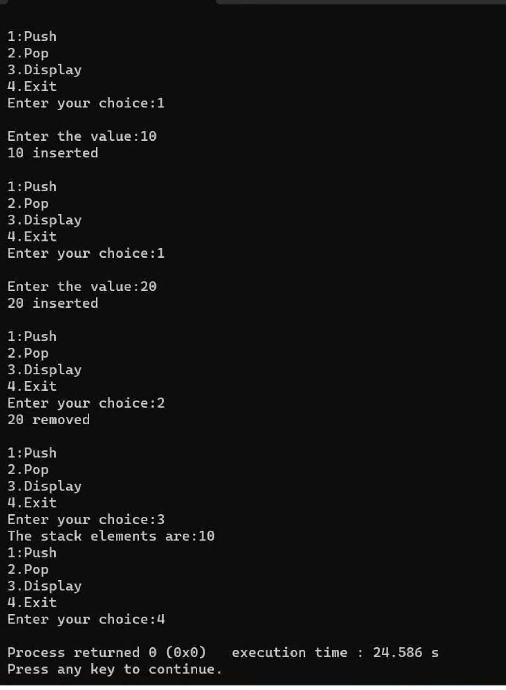

**LAB PROGRAM 2:**

**Write a program to convert a given valid parenthesized infix arithmetic expression to postfix expression. The expression consists of single character operands and the binary operators + (plus), - (minus), * (multiply) and / (divide).**

#include<stdio.h> #include<string.h>

int ind=0,top=-1,pos=0,length;

char symbol,temp,infix[20],postfix[20],stack[20]; void infix to postfix();

void push(char symbol); char pop();

int pred(char symbol); void main(){

printf("Enter the infix expression:"); scanf("%s",infix);

infixtopostfix();

printf("\nInfix expression:%s",infix); printf("\nPostfix expression:%s",postfix);

}

void infixtopostfix(){ length=strlen(infix); push('#'); while(ind<length){

symbol=infix[ind]; switch(symbol){

case '(':push (symbol); break;

case ')':temp=pop();

while (temp !='('){ postfix[pos]=temp; pos++; temp=pop(); }

break;

case '+':

case '-':

case '*':

case '/': while(pred(stack[top])>=pred(symbol)){

temp=pop(); postfix[pos++]=temp; }

push(symbol); break;

default:postfix[pos++]=symbol; } ind++;}

while(top >0) { temp=pop(); postfix[pos++]=temp; }}

void push(char symbol){ top=top+1; stack[top]=symbol;}

char pop(){ char symbol;

symbol=stack[top]; top=top-1;

return (symbol);} int pred(char symbol){

int p;

switch(symbol){ case '*':

case'/':p=2; break;

case '+': case '-':p=1; break;

case '(':p=0; break;

case '#':p=-1; break; }

return(p);}

**OUTPUT:**

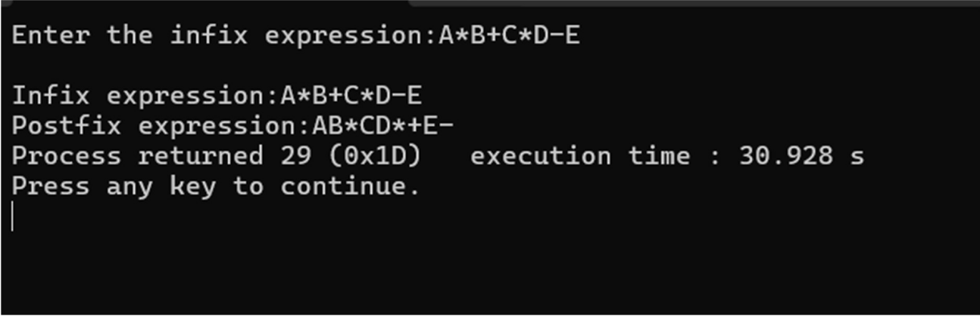

**LAB PROGRAM 3:**

* 1. **Write a program to simulate the working of a queue of integers using an array.Provide the following operations: Insert, Delete, Display.The program should print appropriate messages for queue empty and queue overflow conditions.**

#include <stdio.h> #include <conio.h> #define MAX 10 int queue[MAX];

int front = -1, rear = -1; void insert();

int delete_element(); void display();

int main(){

int option, val; do{

printf("\n ***** MAIN MENU *****"); printf("\n 1. Insert an element"); printf("\n 2. Delete an element"); printf("\n 3. Display the queue"); printf("\n 4. EXIT");

printf("\n Enter your option :"); scanf("%d", &option); switch(option) {

case 1:insert(); break;

case 2:val = delete_element(); if (val != -1)

printf("\n The number deleted is : %d", val); break;

case 3:display(); break; }

}while(option != 4); getch();

return 0;} void insert(){ int num;

printf("\n Enter the number to be inserted in the queue : "); scanf("%d", &num);

if(rear == MAX-1) printf("\n OVERFLOW");

else if(front == -1 && rear == -1) front = rear = 0;

else rear++;

queue[rear] = num;

printf("%d inserted successfully",num);} int delete_element(){

int val;

if(front == -1 || front>rear){ printf("\n UNDERFLOW"); return -1;}

else{

val = queue[front]; front++;

if(front > rear) front = rear = -1; return val;}

}

void display(){ int i; printf("\n");

if(front == -1 || front > rear) printf("\n QUEUE IS EMPTY"); else{

for(i = front;i <= rear;i++)

printf("\t %d", queue[i]);}

}

**OUTPUT:**

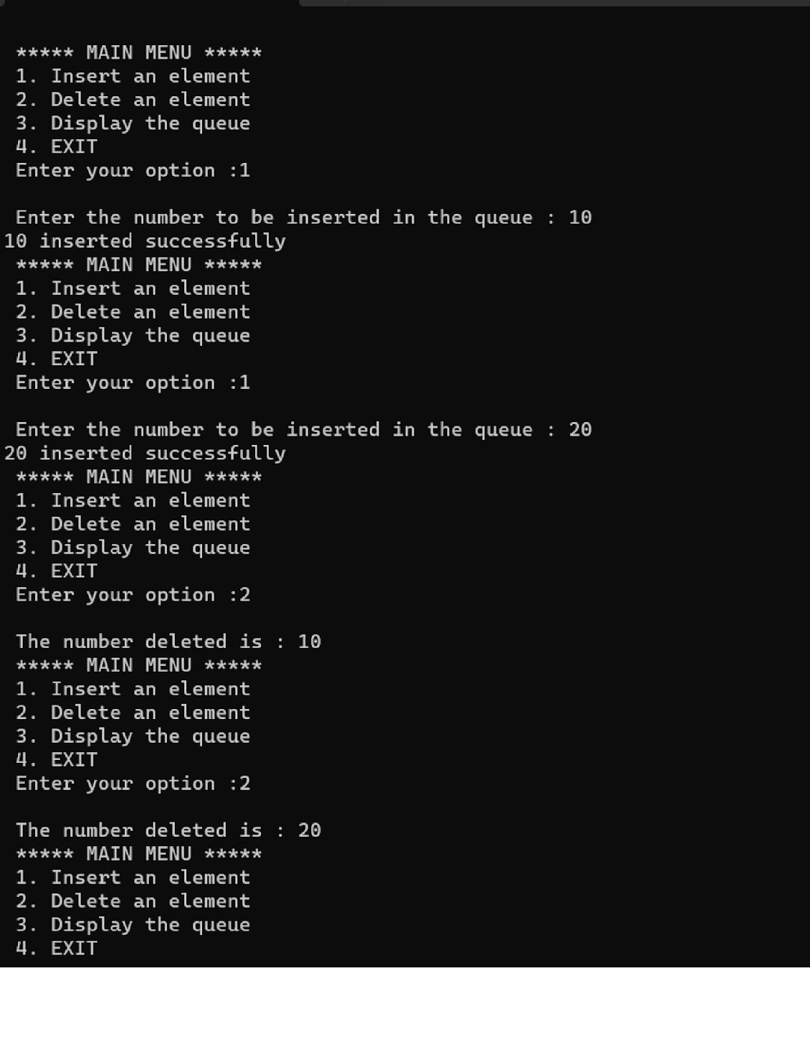

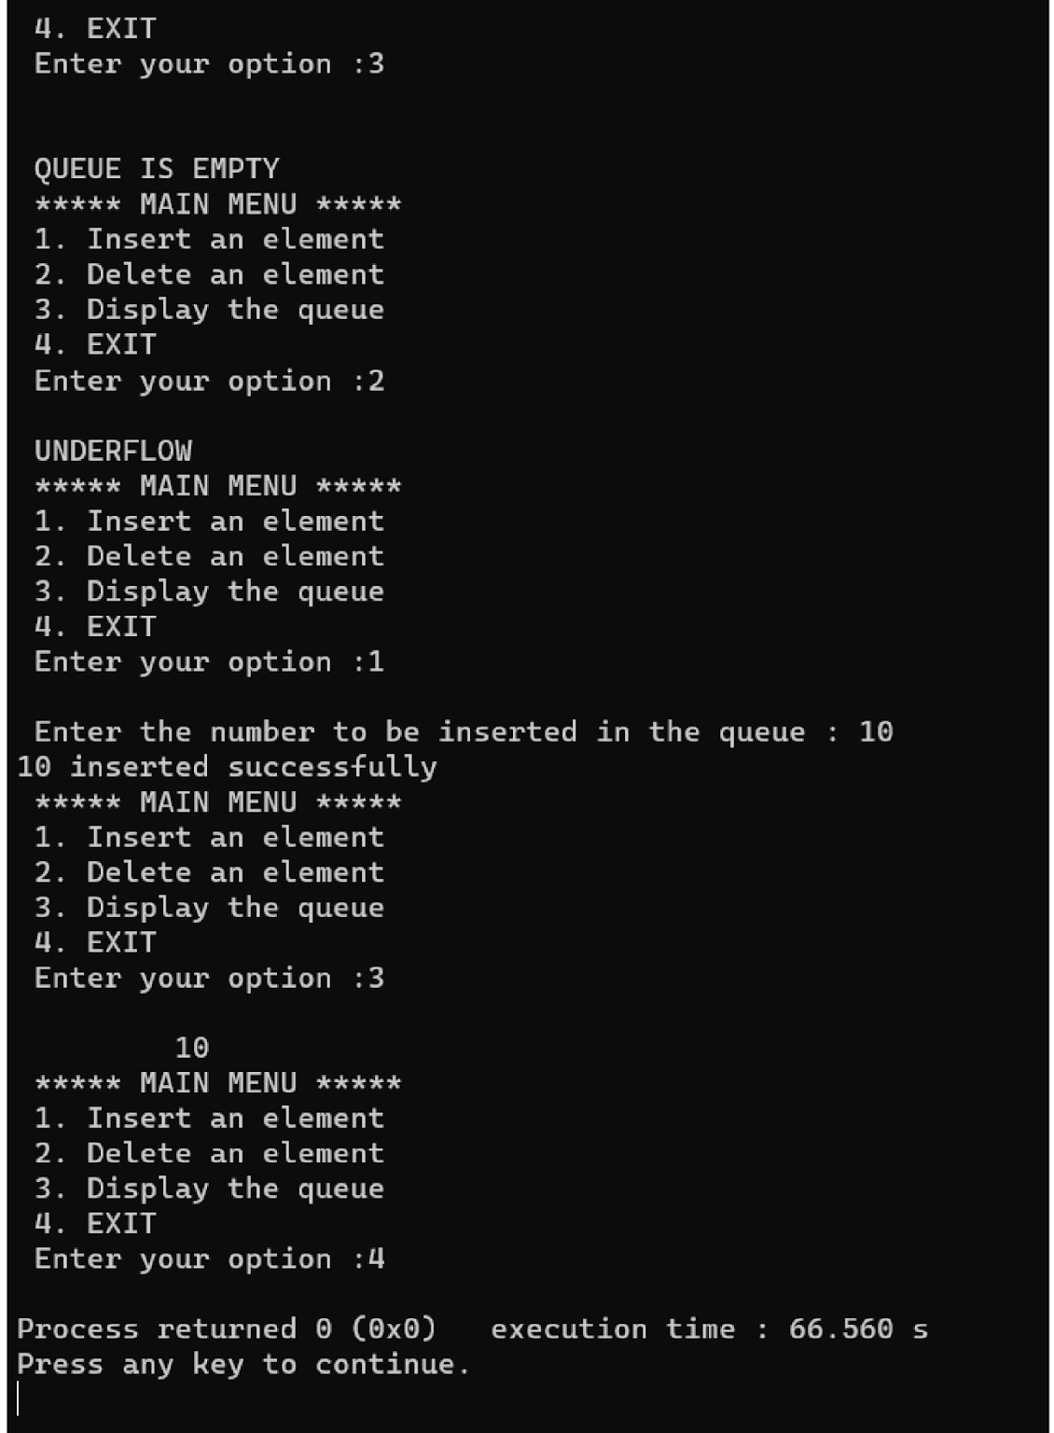

**b ) Write a program to simulate the working of a circular queue of integers using an array. Provide the following operations: Insert, Delete & Display .The program should print appropriate messages for queue empty and queue overflow conditions.**

#include <stdio.h> #include <conio.h> #define MAX 10

int queue[MAX],front=-1,rear=-1; void insert();

int delete_element(); void display();

int main(){

int option, val; do{

printf("\n ***** MAIN MENU *****"); printf("\n 1. Insert an element"); printf("\n 2. Delete an element"); printf("\n 3. Display the queue"); printf("\n 4. EXIT");

printf("\n Enter your option : "); scanf("%d", &option); switch(option) {

case 1:insert(); break;

case 2:val = delete_element(); if(val!=-1)

printf("\n The number deleted is : %d", val); break;

case 3:display(); break; }

}while(option!=4); getch();

return 0;} void insert(){

int num;

printf("\n Enter the number to be inserted in the queue : "); scanf("%d", &num);

if(front==0 && rear==MAX-1) printf("\n OVERFLOW");

else if(front==-1 && rear==-1){ front=rear=0;

queue[rear]=num; printf("Inserted successfully");}

else if(rear==MAX-1 && front!=0){ rear=0;

queue[rear]=num; printf("Inserted successfully");} else{

rear++; queue[rear]=num;

printf("Inserted successfully");}} int delete_element(){

int val;

if(front==-1 && rear==-1) { printf("\n UNDERFLOW"); return -1; }

val = queue[front]; if(front==rear) front=rear=-1; else{ if(front==MAX-1) front=0;

else front++;} return val;

printf("Deleted successfully.");}

void display(){ int i; printf("\n");

if (front ==-1 && rear ==-1) printf ("\n QUEUE IS EMPTY"); else{

printf("The elements of the queue are:"); for(i=front;i!=rear;i=(i+1)%MAX)

printf("\t %d", queue[i]);

printf("\t %d", queue[i]); }

}

**OUTPUT:**

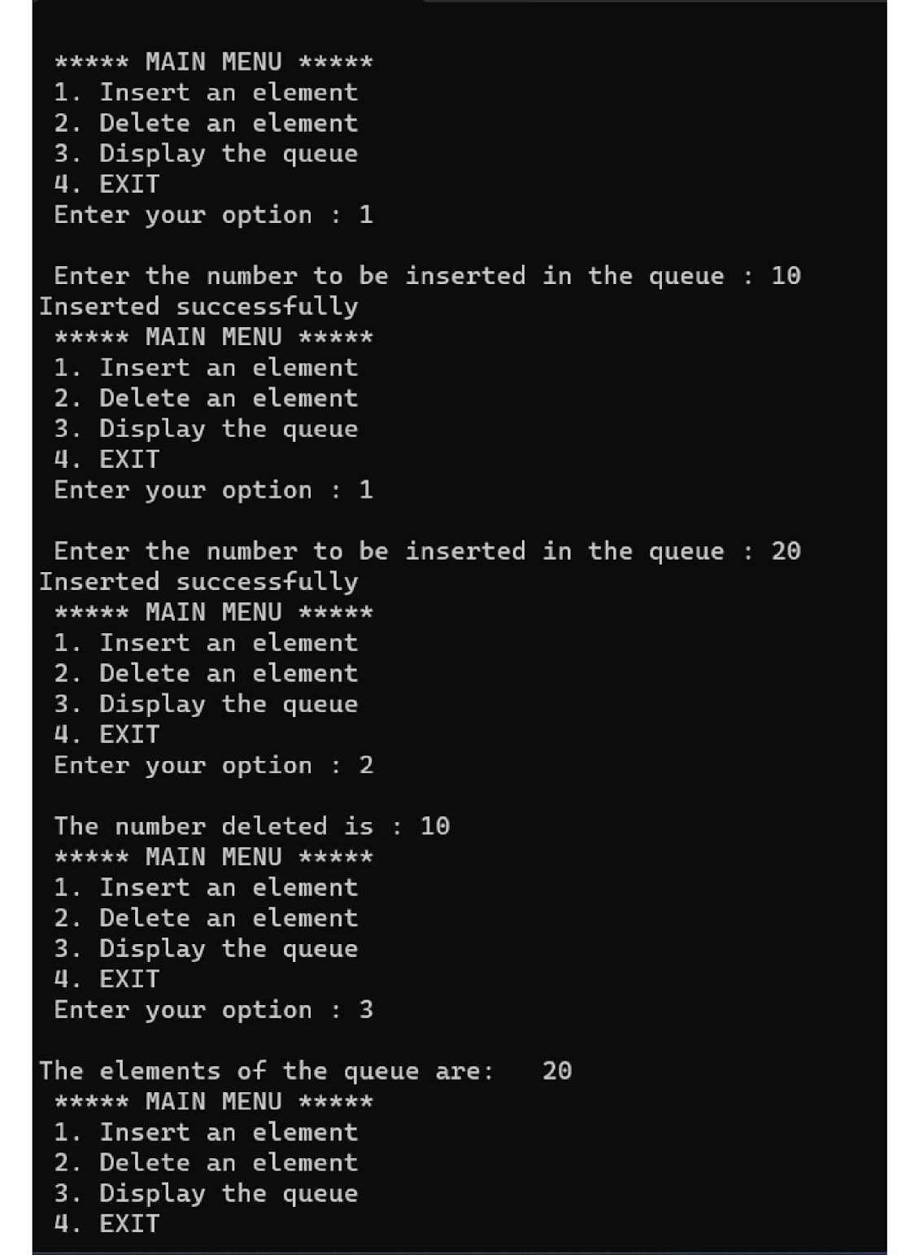

**LAB PROGRAM 4:**

**Write a program to Implement Singly Linked List with following operations**

1. **Create a linked list.**
2. **Insertion of a node at first position, at any position and at end of list.**
3. **Deletion of first element, specified element and last element in the list. Display the contents of the linked list.**

#include <stdio.h> #include <stdlib.h> struct node

{

int data;

struct node *next;

};

struct node *start = NULL;

struct node *insert_beg(struct node *); struct node *insert_end(struct node *); struct node *insert_at_pos(struct node *); struct node *delete_beg(struct node *); struct node *delete_end(struct node *); struct node *delete_at_pos(struct node *); struct node *display(struct node *);

int main(){ int option; do {

printf("\n\n *****MAIN MENU *****"); printf("\n 1: Add a node at the beginning"); printf("\n 2: Add a node at the end");

printf("\n 3: Add a node at a specific position"); printf("\n 4: Delete a node from the beginning"); printf("\n 5: Delete a node from the end");

printf("\n 6: Delete a node from a specific position"); printf("\n 7: Display the list");

printf("\n 8: EXIT");

printf("\n\n Enter your option :"); scanf("%d", &option);

switch (option) {

case 1: start = insert_beg(start); break;

case 2: start = insert_end(start); break;

case 3: start = insert_at_pos(start); break;

case 4:start = delete_beg(start); break;

case 5: start = delete_end(start); break;

case 6: start = delete_at_pos(start); break;

case 7:start = display(start); break; }

} while (option != 8); struct node *temp; while (start != NULL){

temp = start;

start = start->next; free(temp); }

return 0;

}

struct node *insert_beg(struct node *start){ struct node *new_node;

int num;

printf("Enter the data: "); scanf("%d", &num);

new_node = (struct node *)malloc(sizeof(struct node));

new_node->data = num; new_node->next = start; start = new_node;

printf("Inserted at the beginning.\n"); return start;}

struct node *insert_end(struct node *start){ struct node *ptr, *new_node;

int num;

printf("Enter the data: "); scanf("%d", &num);

new_node = (struct node *)malloc(sizeof(struct node)); new_node->data = num;

new_node->next = NULL; if (start == NULL) {

start = new_node;} else {

ptr = start;

while (ptr->next != NULL) { ptr = ptr->next; }

ptr->next = new_node; } printf("Inserted at the end.\n"); return start;}

struct node *insert_at_pos(struct node *start){ struct node *new_node, *ptr, *preptr;

int pos, num;

printf("Enter the position to insert at: "); scanf("%d", &pos);

printf("Enter the data: "); scanf("%d", &num);

new_node = (struct node *)malloc(sizeof(struct node)); new_node->data = num;

new_node->next = NULL;

if (pos == 1) {

new_node->next = start; start = new_node;

printf("Inserted at position %d.\n", pos); return start; }

else {

int i;

ptr = start;

for (int i = 1; i < pos && ptr != NULL; i++) { preptr = ptr;

ptr = ptr->next; }

if (ptr == NULL && pos > i {

printf("Invalid position. Node can't be inserted.\n"); return start; }

preptr->next = new_node; new_node->next = ptr;

printf("Inserted at position %d.\n", pos); return start’}}

struct node *delete_beg(struct node *start){ struct node *ptr;

ptr = start;

if (ptr == NULL) {

printf("Empty list. Can't be deleted.\n"); return start;}

else {

start = start->next; free(ptr);

printf("Deleted at the beginning.\n"); return start; }

}

struct node *delete_end(struct node *start){

struct node *ptr, *ptr1; ptr = start;

if (ptr == NULL) {

printf("Empty list. Can't be deleted.\n"); return start; }

else if (ptr->next == NULL){ free(ptr);

start = NULL;

printf("Deleted at the end.\n"); return start;}

else{

while (ptr->next != NULL) { ptr1 = ptr;

ptr = ptr->next;

}

ptr1->next = NULL; free(ptr);

printf("Deleted at the end.\n"); return start; }

}

struct node *delete_at_pos(struct node *start){ struct node *ptr, *preptr;

int pos;

printf("Enter the position to delete: "); scanf("%d", &pos);

if (start == NULL) {

printf("Empty list. Can't be deleted.\n"); return start; }

ptr = start;

if (pos == 1) {

start = start->next; free(ptr);

printf("Deleted at position %d.\n", pos); return start; }

else {

for (int i = 1; i < pos && ptr != NULL; i++){ preptr = ptr;

ptr = ptr->next; } if (ptr == NULL) {

printf("Invalid position. Node can't be deleted.\n"); return start;}

preptr->next = ptr->next; free(ptr);

printf("Deleted at position %d.\n", pos); return start; }}

struct node *display(struct node *start){ struct node *ptr;

ptr = start;

if (ptr == NULL){ printf("Empty list.\n"); return start;}

else{

printf("Linked list elements: "); while (ptr != NULL){

printf("%d\t", ptr->data); ptr = ptr->next;}

printf("\n"); return start;}}

**OUTPUT:**

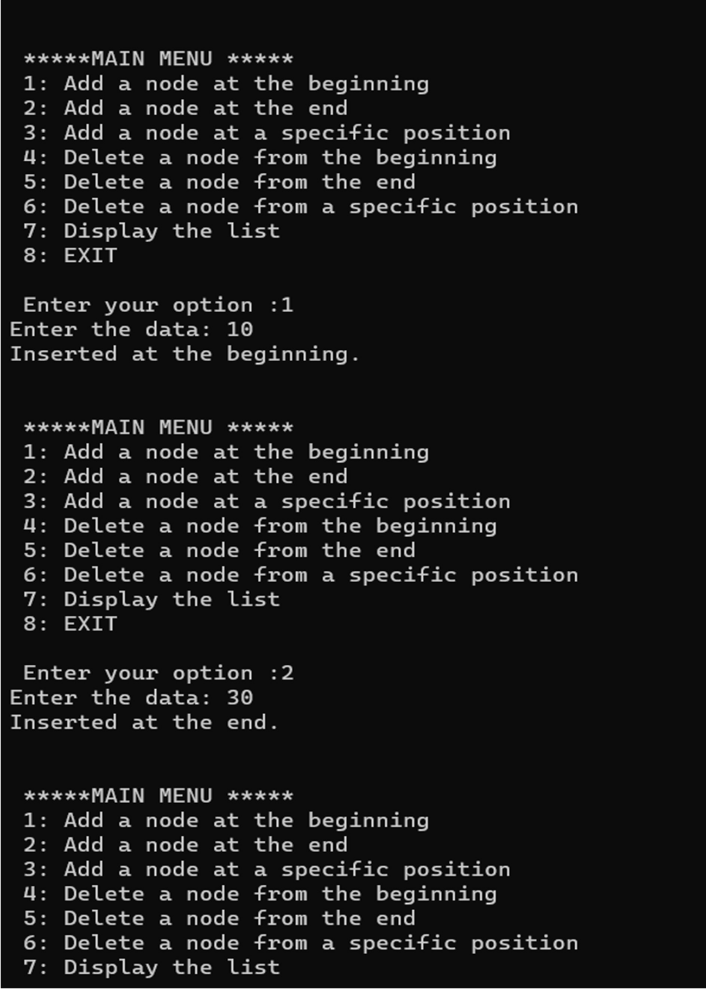

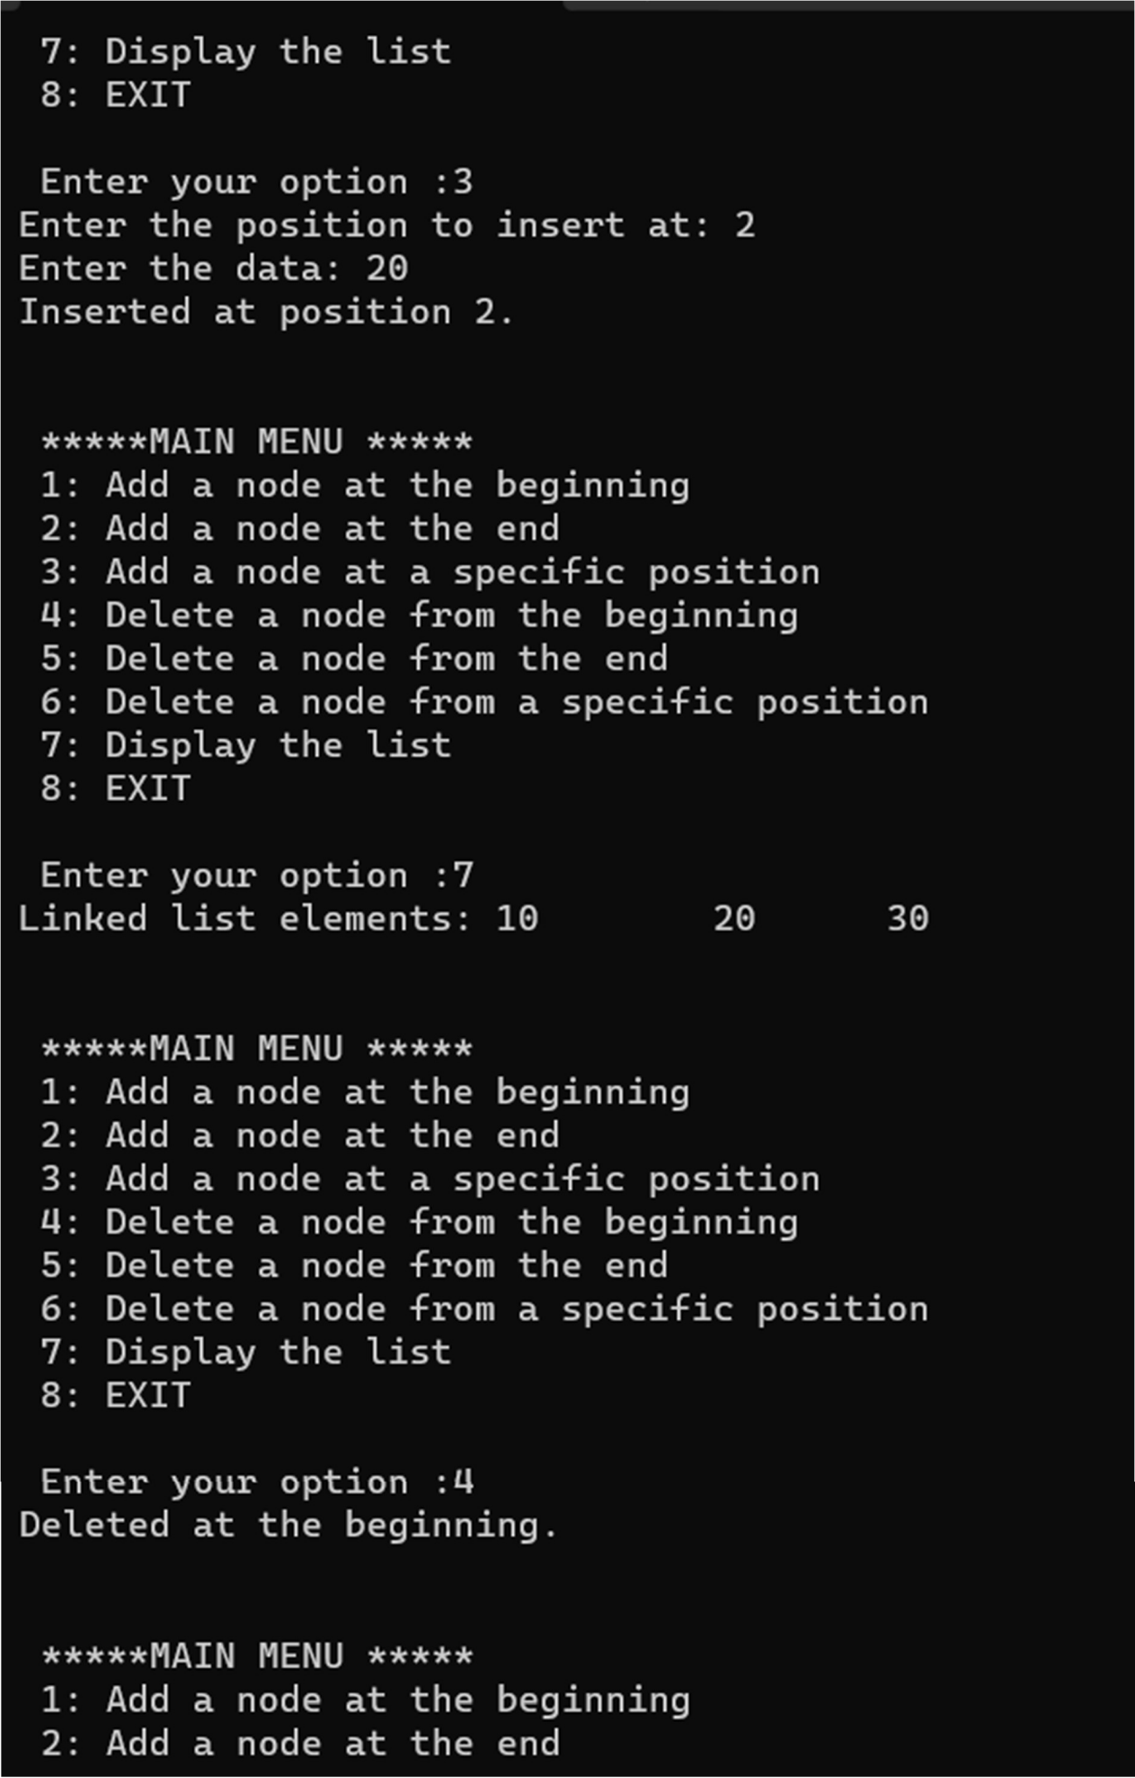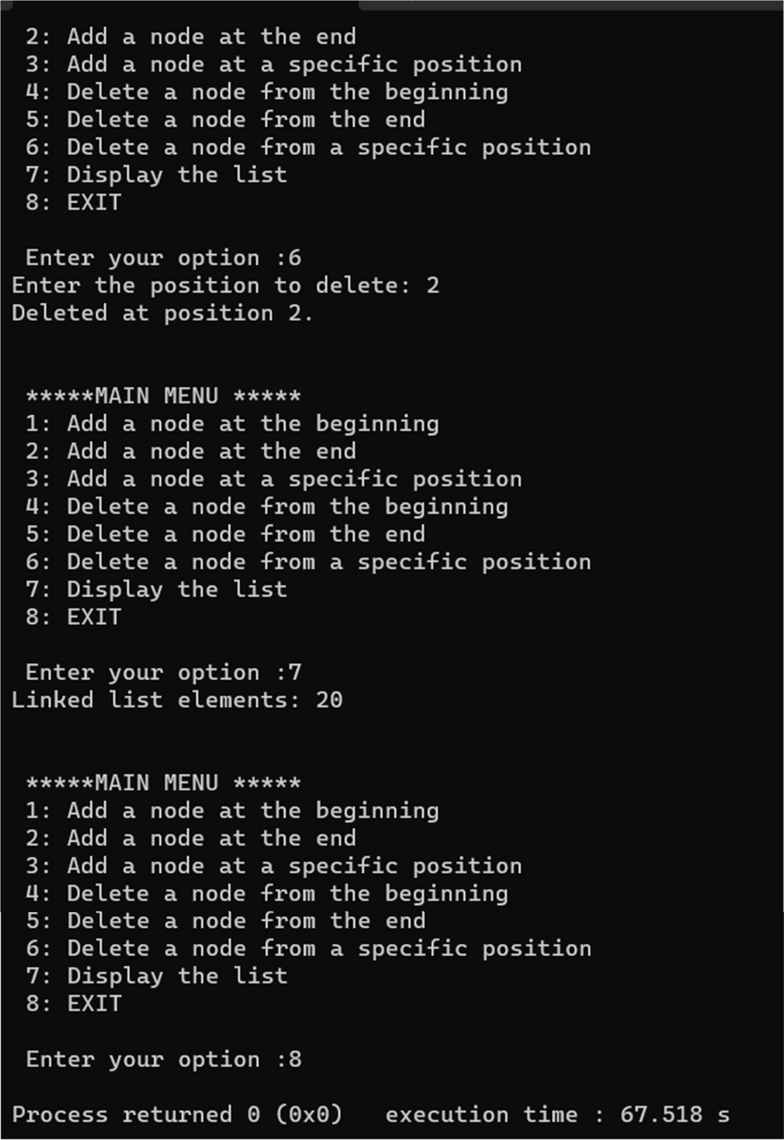

**LAB PROGRAM 5:**

1. **WAP to Implement Single Link List with following operations: Sort the linked list, Reverse the linked list and Concatenation of two linked lists.**

#include <stdio.h> #include <stdlib.h> struct Node {

int data;

struct Node* next;

};

void insertAtBeginning(struct Node** head, int data) {

struct Node* newNode = (struct Node*)malloc(sizeof(struct Node)); newNode->data = data;

newNode->next = *head;

*head = newNode;

}

void printList(struct Node* head) { while (head != NULL) {

printf("%d ", head->data); head = head->next; }

printf("\n");}

void sortList(struct Node** head) { struct Node *current, *nextNode; int temp;

current = *head;

while (current != NULL) { nextNode = current->next; while (nextNode != NULL) {

if (current->data > nextNode->data) { temp = current->data;

current->data = nextNode->data; nextNode->data = temp; }

nextNode = nextNode->next;} current = current->next;}

}

void reverseList(struct Node** head) { struct Node *prev, *current, *nextNode; prev = NULL;

current = *head;

while (current != NULL) { nextNode = current->next; current->next = prev;

prev = current; current = nextNode; }

*head = prev;}

void concatenateLists(struct Node** list1, struct Node* list2) { if (*list1 == NULL) {

*list1 = list2; return; }

struct Node* temp = *list1; while (temp->next != NULL) {

temp = temp->next; } temp->next = list2;}

void main() {

struct Node* list1 = NULL; struct Node* list2 = NULL; int choice;

int data;

while(1) {

printf("\n1. Insert into List 1\n"); printf("2. Insert into List 2\n"); printf("3. Sort List 1\n"); printf("4. Reverse List 2\n"); printf("5. Concatenate Lists\n"); printf("6. Print Lists\n");

printf("7. Exit\n"); printf("Enter your choice: "); scanf("%d", &choice); switch (choice) {

case 1: printf("Enter data to insert into List 1: "); scanf("%d", &data); insertAtBeginning(&list1, data);

break;

case 2:printf("Enter data to insert into List 2: "); scanf("%d", &data); insertAtBeginning(&list2, data);

break;

case 3:sortList(&list1); printf("List 1 sorted.\n"); break;

case 4:reverseList(&list1); printf("List 1 reversed.\n"); break;

case 5:concatenateLists(&list1, list2); printf("Lists concatenated.\n"); break;

case 6:

printf("List 1: "); printList(list1); printf("List 2: "); printList(list2); break;

case 7:

exit(0); break;

default:

printf("Invalid choice\n");

}

}

}

**OUTPUT:**

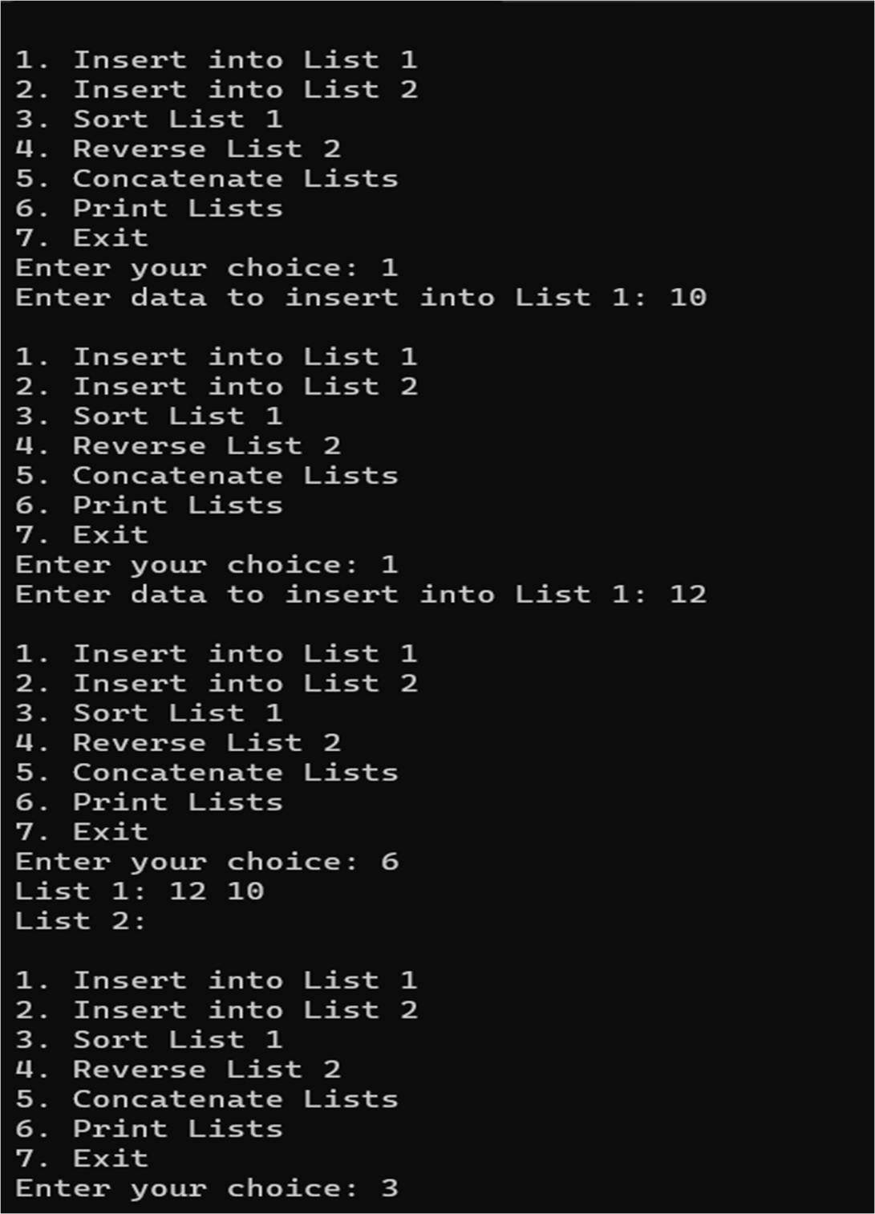

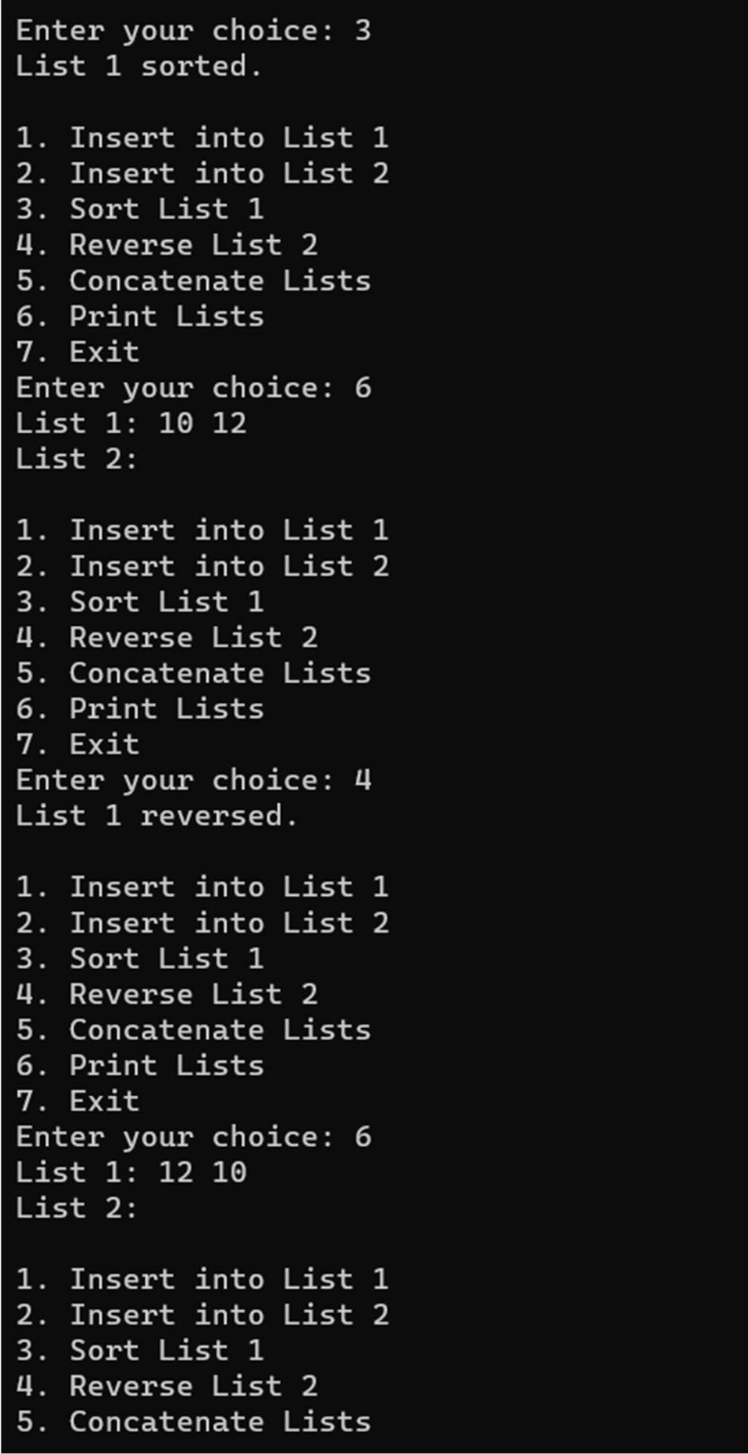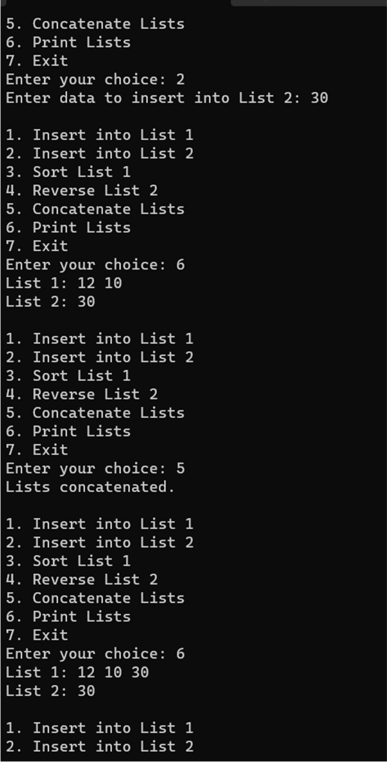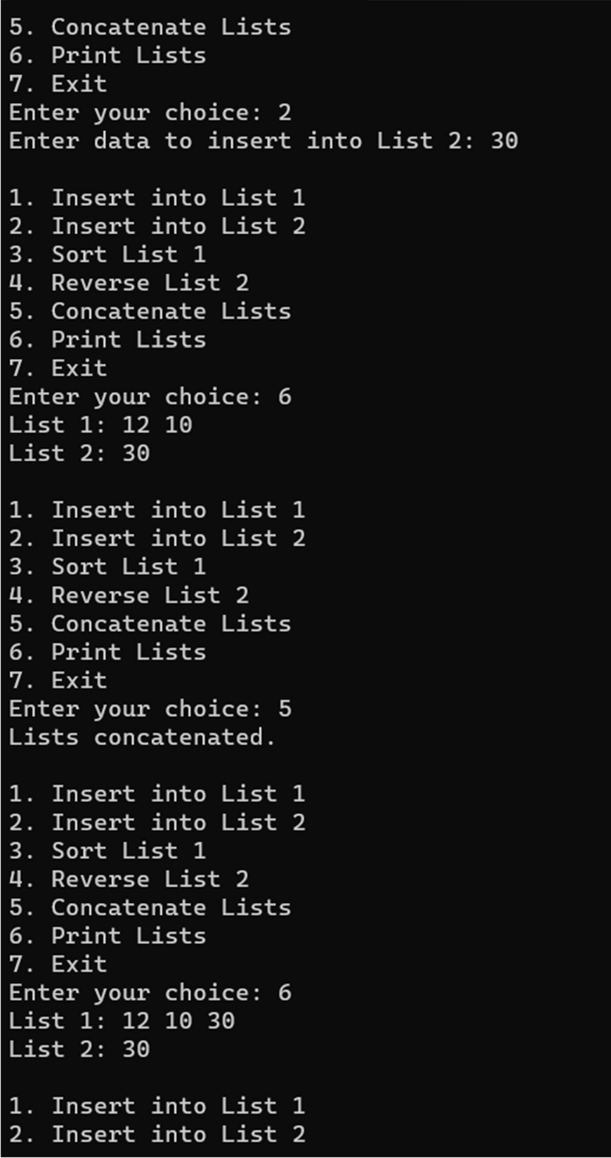

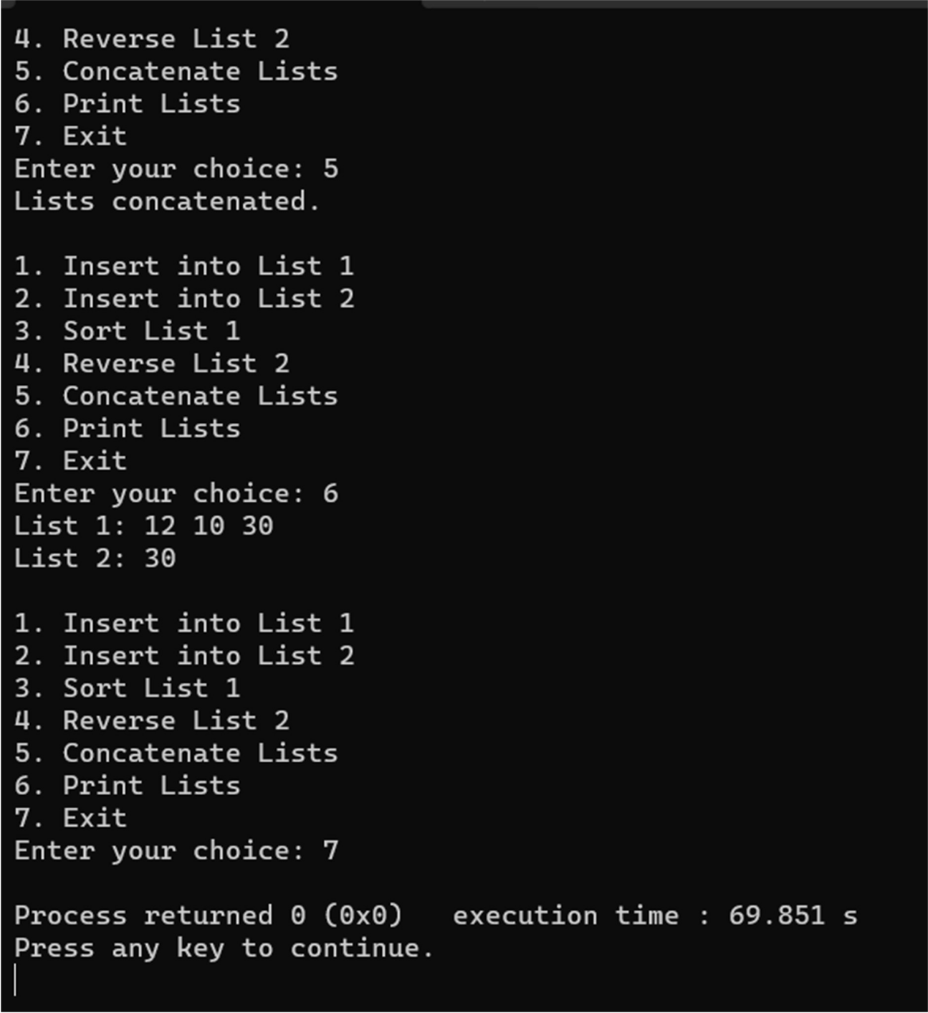

**LAB PROGRAM 6:**

**Write a program to Implement Single Link List to simulate Stack & Queue Operations.**

#include <stdio.h> #include <stdlib.h> struct stack

{

int data;

struct stack *next;

};

struct stack *top = NULL;

struct stack *push(struct stack *, int); struct stack *display(struct stack *); struct stack *pop(struct stack *); void main(){

int val, option; while(1){

printf("\n *****MAIN MENU*****"); printf("\n 1. PUSH");

printf("\n 2. POP");

printf("\n 3. DISPLAY");

printf("\n 4. EXIT");

printf("\n Enter your option: "); scanf("%d", &option); switch(option){

case 1:

printf("\n Enter the number to be pushed on stack: "); scanf("%d", &val);

top = push(top, val); break;

case 2:

top = pop(top); break;

case 3:

top = display(top); break;

case 4:exit(0); default:printf("Invalid input"); }}

}

struct stack *push(struct stack *top, int val){ struct stack *ptr;

ptr = (struct stack*)malloc(sizeof(struct stack)); ptr -> data = val;

if(top == NULL){ ptr -> next = NULL; top = ptr;

printf("The value %d is inserted",val);} else{

ptr -> next = top; top = ptr;

printf("The value %d is inserted",val);} return top;}

struct stack *display(struct stack *top){ struct stack *ptr;

ptr = top;

if(top == NULL)

printf("\n STACK IS EMPTY"); else{

printf("The stack elements are:"); while(ptr != NULL) {

printf("\n %d", ptr -> data); ptr = ptr -> next; }}

return top;}

struct stack *pop(struct stack *top){ struct stack *ptr;

ptr = top;

if(top == NULL)

printf("\n STACK UNDERFLOW");

else{

top = top -> next;

printf("\n The value being deleted is: %d", ptr -> data); free(ptr);}

return top;}

**OUTPUT:**

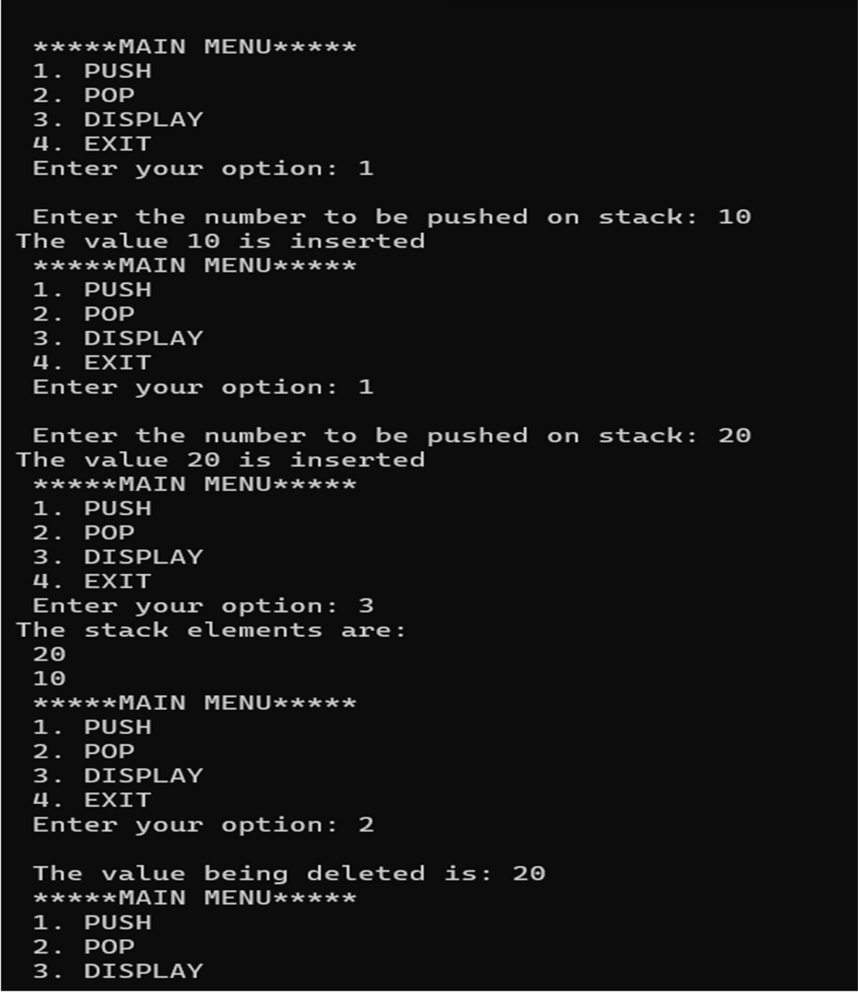

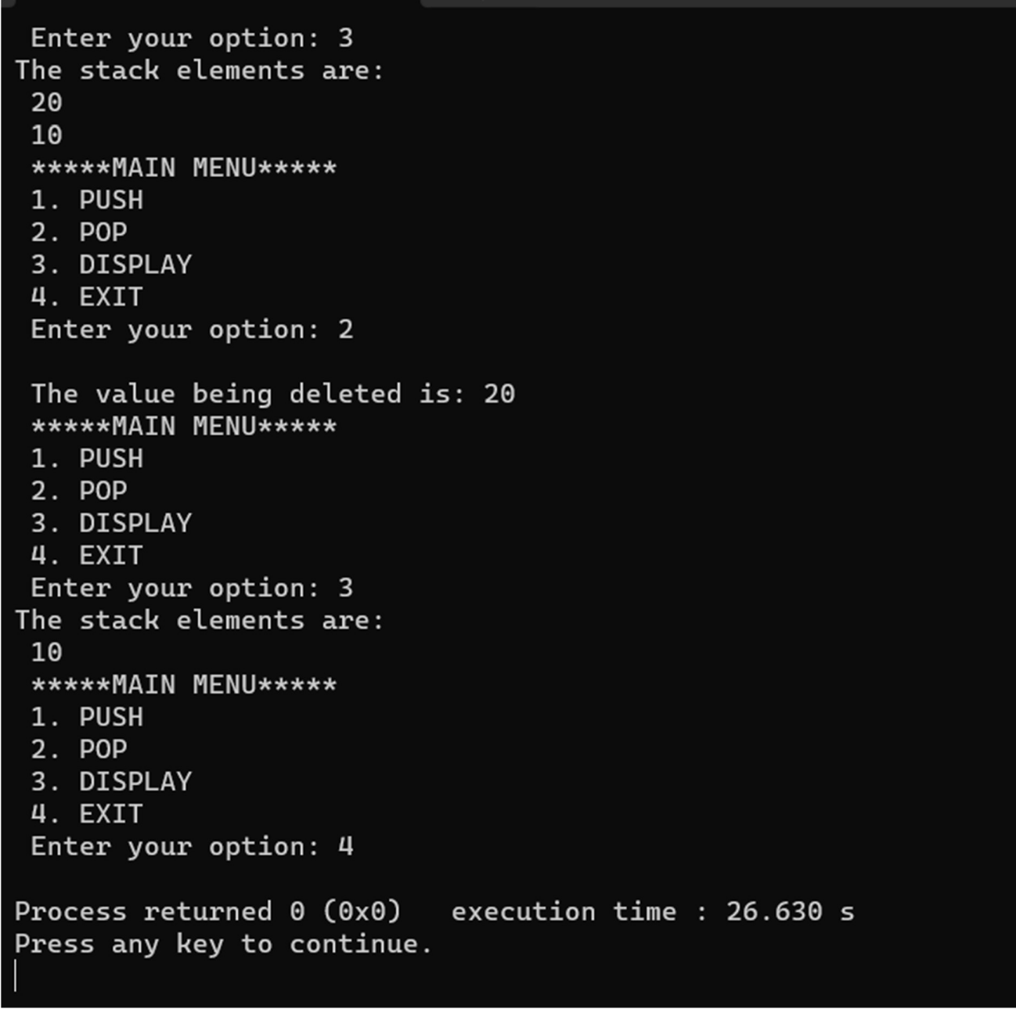

**Queue Implementation:** #include <stdio.h> #include<stdlib.h>

struct node

{

int data;

struct node *next;

};

struct queue

{

struct node *front; struct node *rear;

};

struct queue *createQueue(){

struct queue* q = (struct queue*)malloc(sizeof(struct queue)); q->front = q->rear = NULL;

return q;} struct queue *q;

struct queue *insert(struct queue *,int);

struct queue *delete_element(struct queue *); struct queue *display(struct queue *);

void main(){ int val, option;

q=createQueue(q); while(1){

printf("\n *****MAIN MENU*****"); printf("\n 1. INSERT");

printf("\n 2. DELETE");

printf("\n 3. DISPLAY");

printf("\n 4. EXIT");

printf("\n Enter your option : "); scanf("%d", &option); switch(option) {

case 1:

printf("\n Enter the number to insert in the queue:"); scanf("%d", &val);

q = insert(q,val);

printf("\nThe value %d is inserted into the queue.\n",val); break;

case 2:

q = delete_element(q); break;

case 3:

q = display(q); break;

case 4:exit(0); default:printf("Invalid input"); }}}

struct queue *insert(struct queue *q,int val){ struct node *ptr;

ptr = (struct node*)malloc(sizeof(struct node)); ptr -> data = val;

if(q -> front == NULL){ q -> front = ptr;

q -> rear = ptr;

q -> front -> next = q -> rear -> next = NULL;} else{

q -> rear -> next = ptr; q -> rear = ptr;

q -> rear -> next = NULL;} return q;}

struct queue *display(struct queue *q){ struct node *ptr;

ptr = q -> front; if(ptr == NULL)

printf("\n QUEUE IS EMPTY\n"); else{

printf("\n"); while(ptr!=q -> rear) {

printf("%d\t", ptr -> data); ptr = ptr -> next; } printf("%d\t", ptr -> data);} return q;}

struct queue *delete_element(struct queue *q){ struct node *ptr;

ptr = q -> front;

if(q -> front == NULL) printf("\n UNDERFLOW\n");

else{

q -> front = q -> front -> next;

printf("\n The value being deleted is : %d\n", ptr -> data); free(ptr);}

return q;

}

**OUTPUT:**

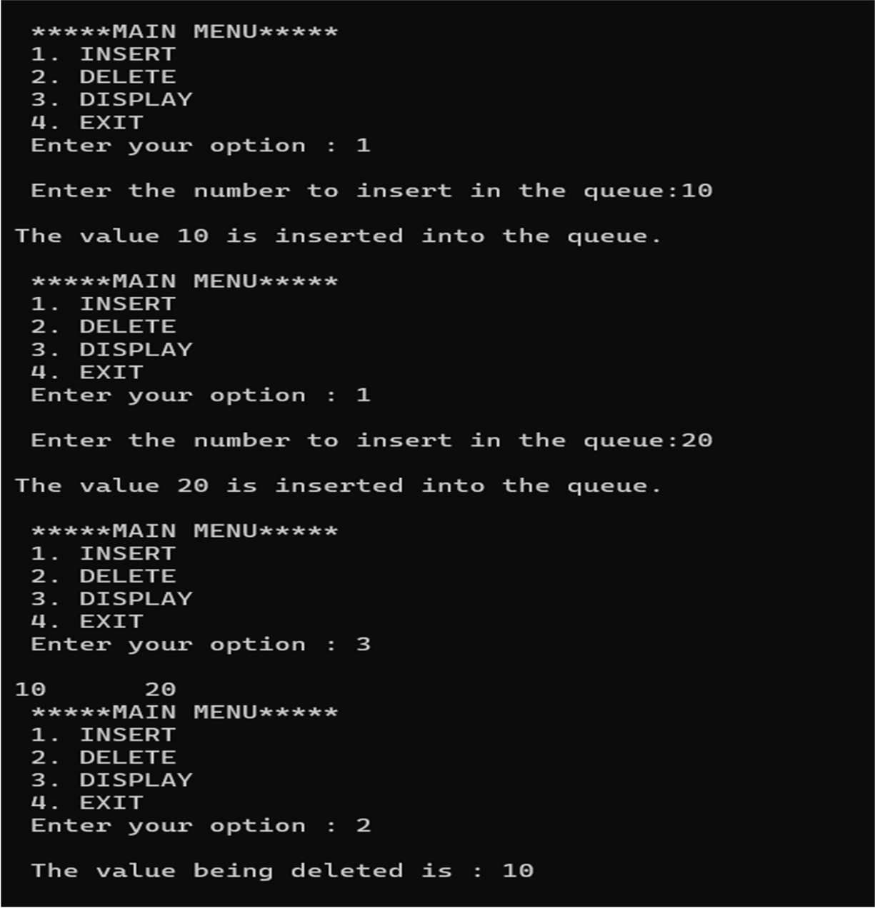

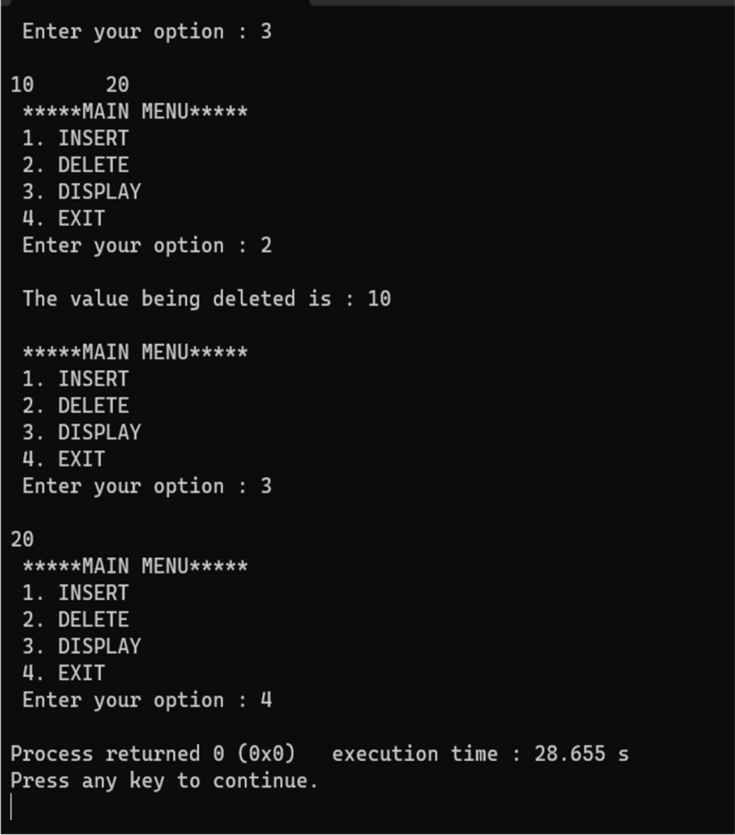

**LAB PROGRAM 7:**

**Write a program to Implement doubly link list with primitive operations.**

* 1. **Create a doubly linked list.**
  2. **Insert a new node to the left of the node.**
  3. **Delete the node based on a specific value**
  4. **Display the contents of the list**

#include <stdio.h> #include <stdlib.h> struct Node {

int data;

struct Node* prev; struct Node* next;

};

struct Node* head = NULL; void createlist() {

int i, n;

struct Node* newNode; struct Node* temp;

printf("Enter the number of elements:"); scanf("%d", &n);

for (i = 0; i < n; i++) {

newNode = (struct Node*)malloc(sizeof(struct Node)); printf("Enter the element: ");

scanf("%d", &newNode->data); if (head == NULL) {

head = temp = newNode; head->prev = NULL; temp->next = NULL;

} else {

temp->next = newNode; newNode->prev = temp; temp = newNode;

temp->next = NULL; } } printf("List created successfully.\n");}

void insertLeft(struct Node* temp, int data) { struct Node* newNode;

if (temp == NULL) {

printf("Target node doesn't exist!\n"); return; }

newNode = (struct Node*)malloc(sizeof(struct Node)); newNode->data = data;

newNode->next = temp; newNode->prev = temp->prev; if (temp->prev != NULL) {

temp->prev->next = newNode; } temp->prev = newNode;

if (head == temp) { head = newNode; }

printf("Node inserted successfully.\n");} void deleteNode(int key) {

struct Node* current = head; while (current != NULL) {

if (current->data == key) {

if (current->prev != NULL) {

current->prev->next = current->next; } if (current->next != NULL) {

current->next->prev = current->prev;

}

if (current == head) { head = current->next; }

free(current);

printf("Node deleted successfully.\n"); return; }

current = current->next;}

printf("Node with value %d not found!\n", key);} void printList() {

struct Node* temp = head; if (temp == NULL) {

printf("List is empty!\n"); return; }

printf("Doubly linked list: "); while (temp != NULL) {

printf("%d ", temp->data); temp = temp->next;}

printf("\n");} int main() {

int choice, data, targetValue, deleteValue; while(1) {

printf("\nDoubly Linked List Operations:\n"); printf("1. Create linked list\n");

printf("2. Insert left of node\n"); printf("3. Delete node by value\n"); printf("4. Print the list\n"); printf("5. Exit\n");

printf("Enter your choice: "); scanf("%d", &choice);

switch (choice) { case 1: createlist();

break;

case 2: printf("Enter the value of the node to insert left of: "); scanf("%d", &targetValue);

printf("Enter the element to insert left of the node: "); scanf("%d", &data);

struct Node* temp = head; while (temp != NULL) {

if (temp->data == targetValue) {

insertLeft(temp, data); break; }

temp = temp->next; } break;

case 3: printf("Enter the value of the node to delete: "); scanf("%d", &deleteValue); deleteNode(deleteValue);

break;

case 4: printList(); break;

case 5: exit(0); break;

default:

printf("Invalid choice!\n");

}

}

return 0;

}

**OUTPUT:**

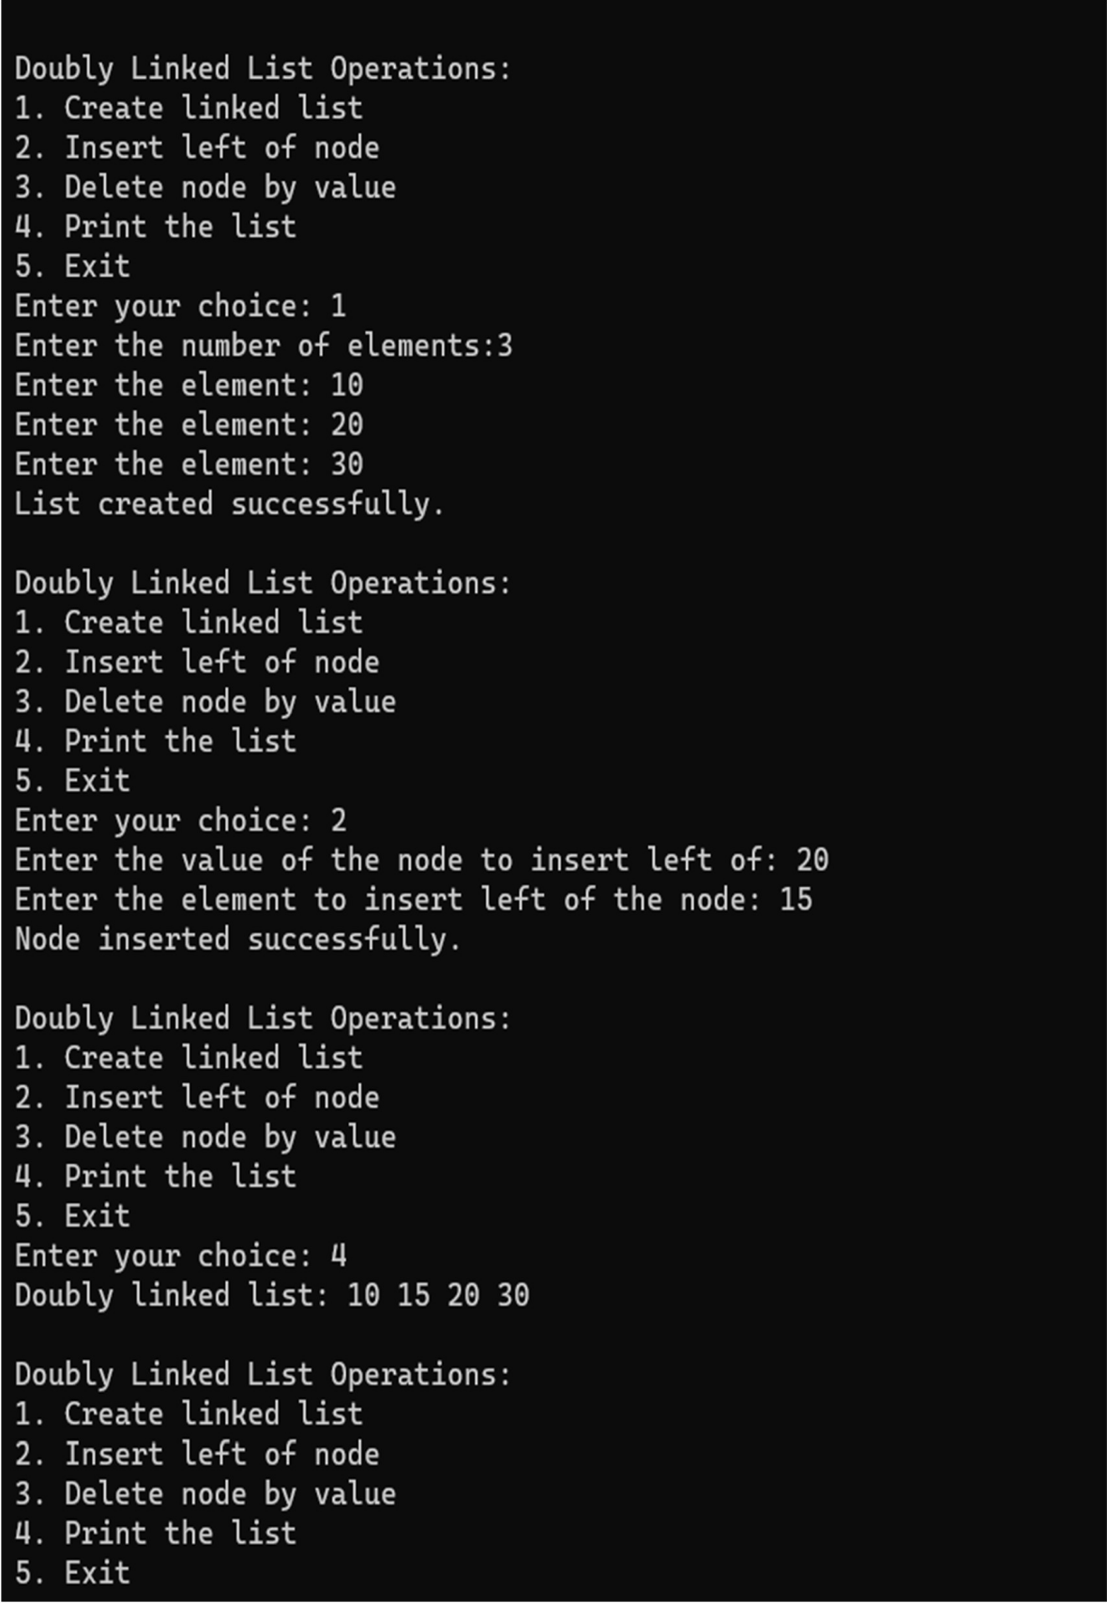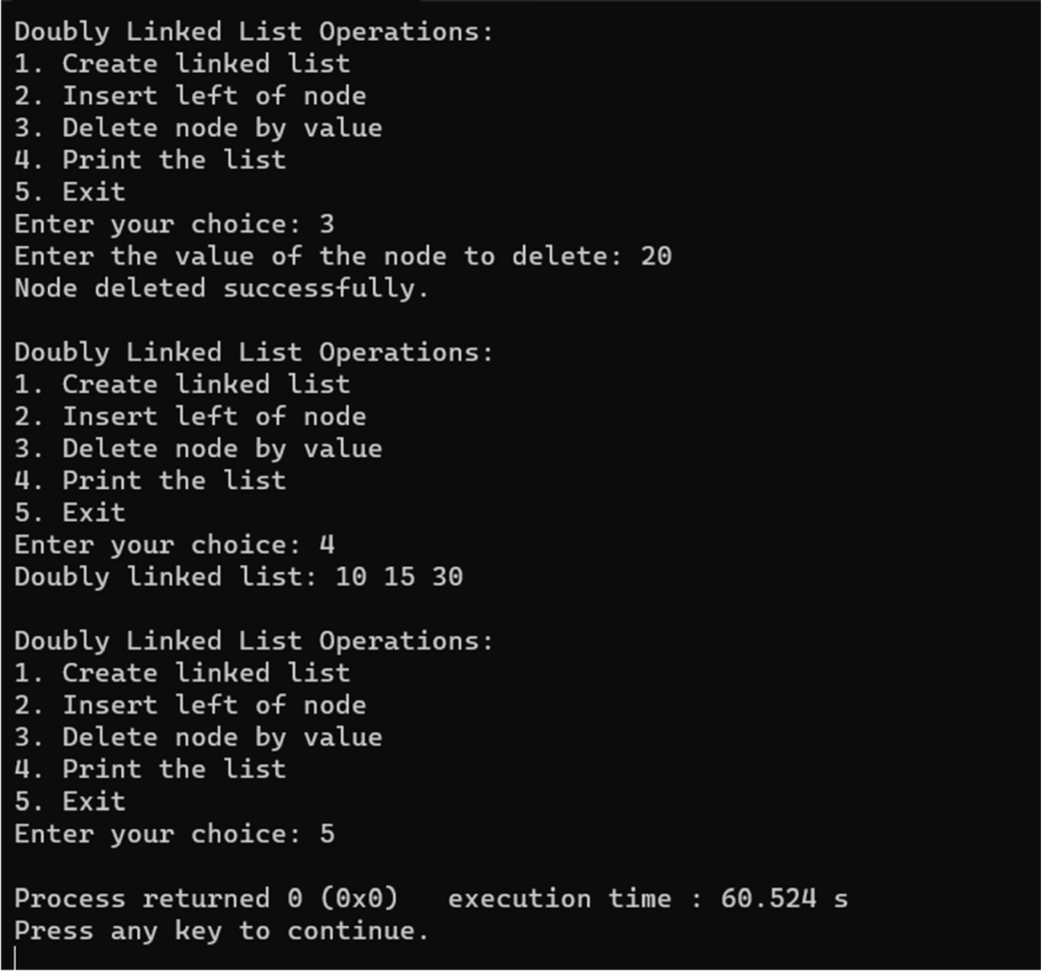

**LAB PROGRAM 8:**

**Write a program**

1. **To construct a binary Search tree.**
2. **To traverse the tree using all the methods i.e., in-order, preorder and post order**
3. **To display the elements in the tree.**

#include <stdio.h> #include <conio.h> #include <malloc.h>

struct node{ int data;

struct node *left; struct node *right;

};

struct node *tree=NULL;

struct node *insertElement(struct node *, int); void preorderTraversal(struct node *);

void inorderTraversal(struct node *); void postorderTraversal(struct node *); void main(){

int option, val; while(1){

printf("\n\n ******MAIN MENU******* \n"); printf("\n 1. Insert Element");

printf("\n 2. Preorder Traversal"); printf("\n 3. Inorder Traversal"); printf("\n 4. Postorder Traversal"); printf("\n 5. Exit");

printf("\n Enter your option : "); scanf("%d", &option); switch(option){

case 1:

printf("\n Enter the value of the new node : ");

scanf("%d", &val);

tree = insertElement(tree, val); break;

case 2:

printf("\n The elements of the tree are : \n"); preorderTraversal(tree);

break; case 3:

printf("\n The elements of the tree are : \n"); inorderTraversal(tree);

break; case 4:

printf("\n The elements of the tree are : \n"); postorderTraversal(tree);

break;

case 5:exit(0); default:printf("Invalid input");}}}

struct node *insertElement(struct node *tree, int val){ struct node *ptr, *nodeptr, *parentptr;

ptr = (struct node*)malloc(sizeof(struct node)); ptr->data = val;

ptr->left = NULL; ptr->right = NULL; if(tree==NULL){ tree=ptr;

tree->left=NULL; tree->right=NULL;} else{ parentptr=NULL; nodeptr=tree;

while(nodeptr!=NULL) { parentptr=nodeptr;

if(val<nodeptr->data) nodeptr=nodeptr->left; else

nodeptr = nodeptr->right; } if(val<parentptr->data) parentptr->left = ptr;

else

parentptr->right = ptr;} return tree;}

void preorderTraversal(struct node *tree){ if(tree != NULL){

printf("%d\t", tree->data); preorderTraversal(tree->left); preorderTraversal(tree->right);}}

void inorderTraversal(struct node *tree){ if(tree != NULL){

inorderTraversal(tree->left); printf("%d\t", tree->data); inorderTraversal(tree->right);}}

void postorderTraversal(struct node *tree){ if(tree != NULL){

postorderTraversal(tree->left); postorderTraversal(tree->right); printf("%d\t", tree->data);}

}

**OUTPUT:**

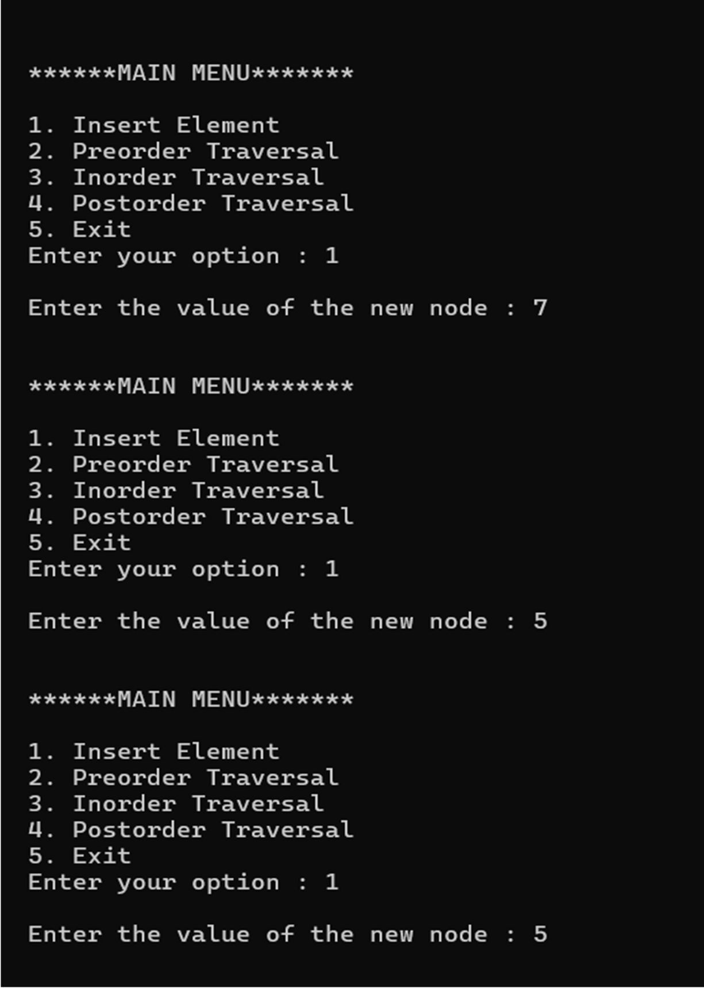

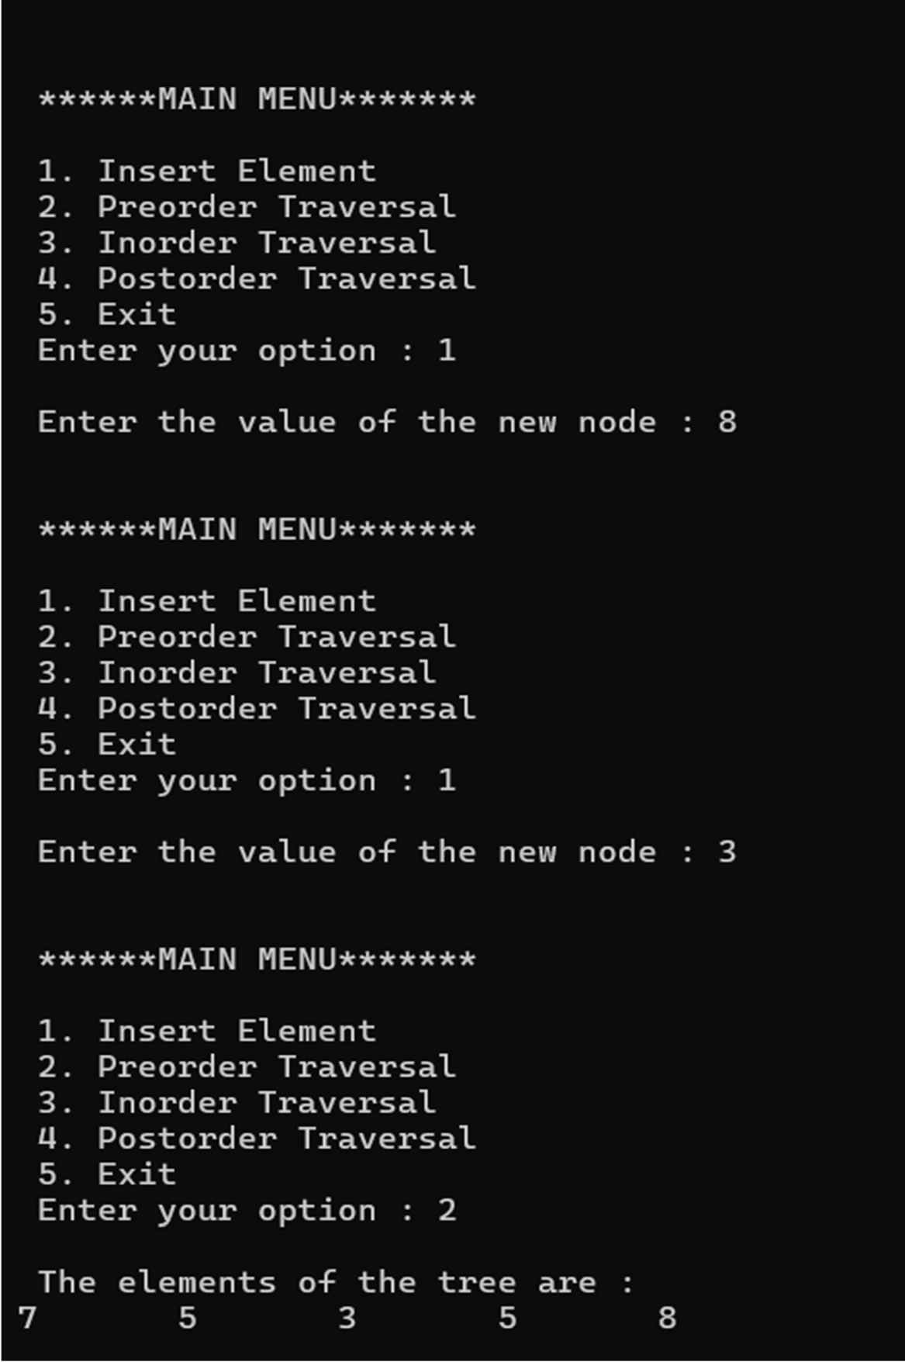

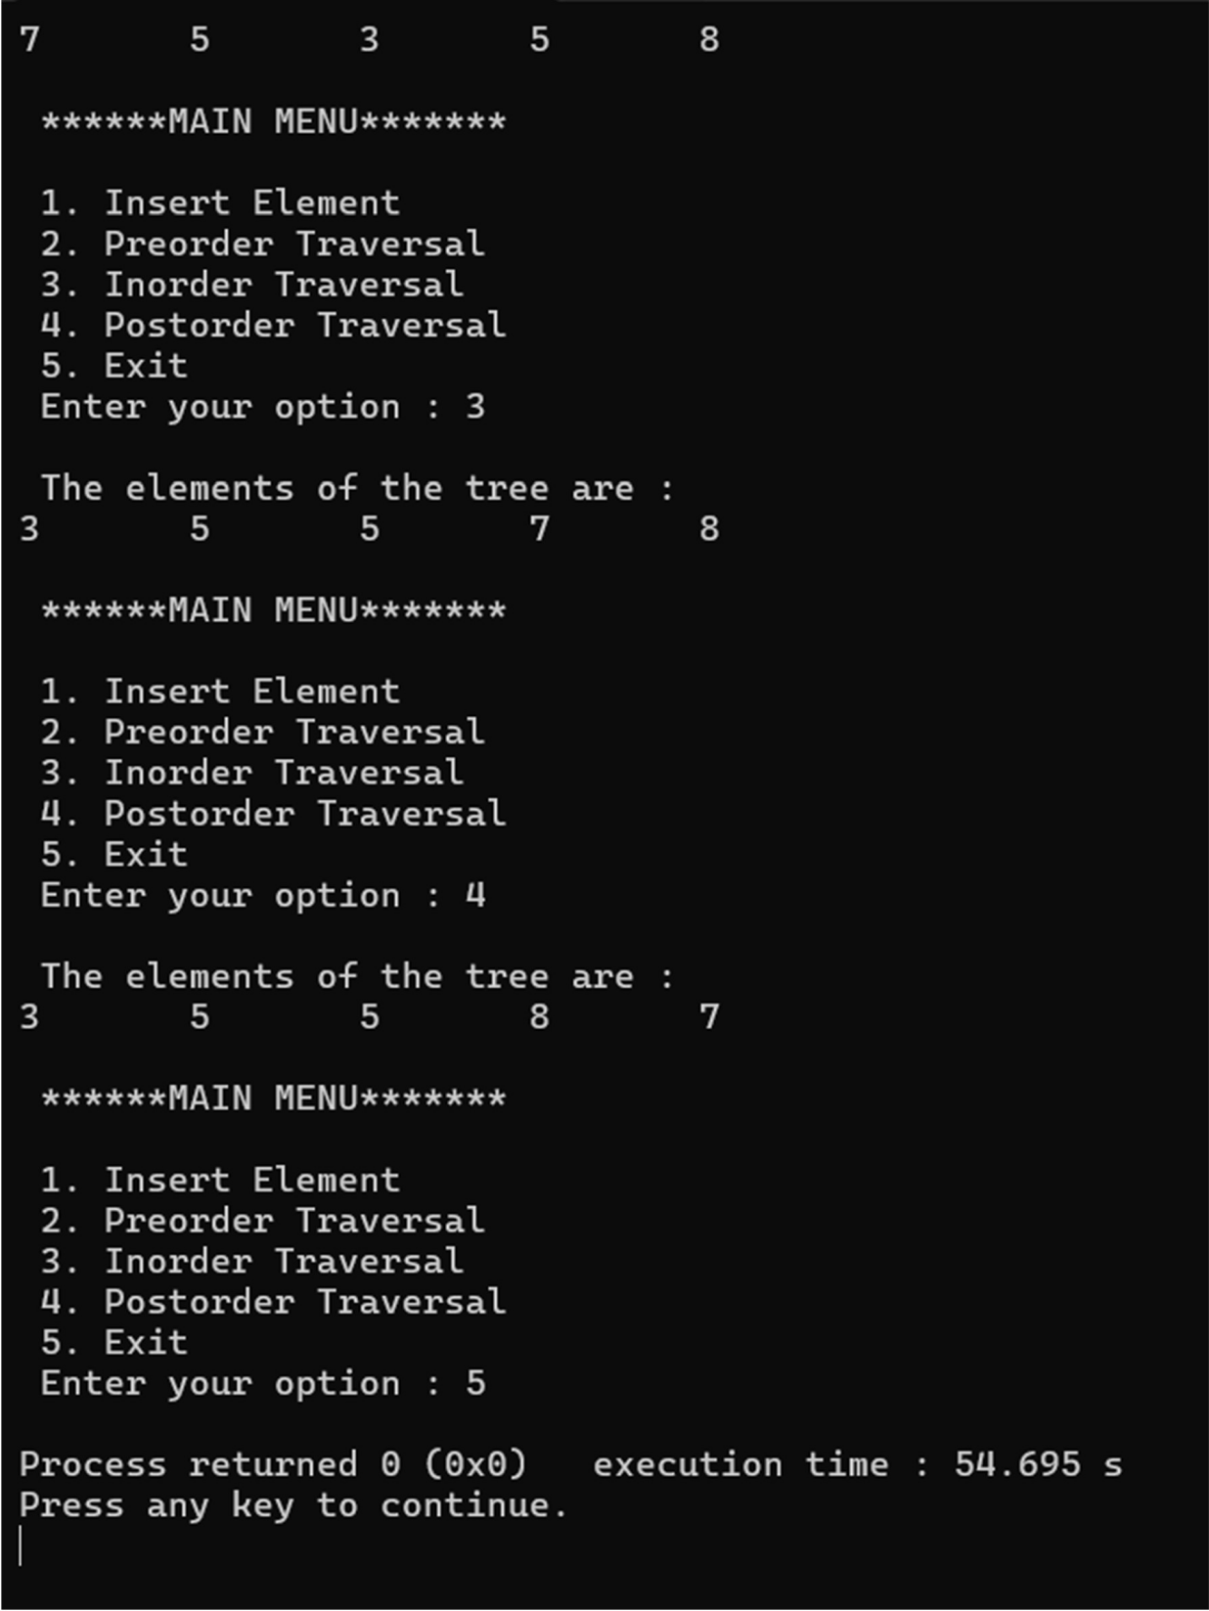

**LAB PROGRAM 9:**

1. **Write a program to traverse a graph using BFS method.**

#include <stdio.h> #define MAX 5

void breadth_first_search(int adj[][MAX],int visited[],int start){ int queue[MAX],rear = -1,front = -1, i;

queue[++rear] = start; visited[start] = 1; while(rear != front){ start = queue[++front]; if(start == 4) printf("%c\t",start+65); else

printf("%c \t",start + 65); for(i = 0; i < MAX; i++) {

if(adj[start][i] == 1 && visited[i] == 0){ queue[++rear] = i;

visited[i] = 1; } }}

}

int main(){

int visited[MAX] = {0}; int adj[MAX][MAX], i, j;

printf("\n Enter the adjacency matrix: "); for(i = 0; i < MAX; i++)

for(j = 0; j < MAX; j++) scanf("%d", &adj[i][j]);

breadth_first_search(adj,visited,0); return 0;

}

**OUTPUT:**

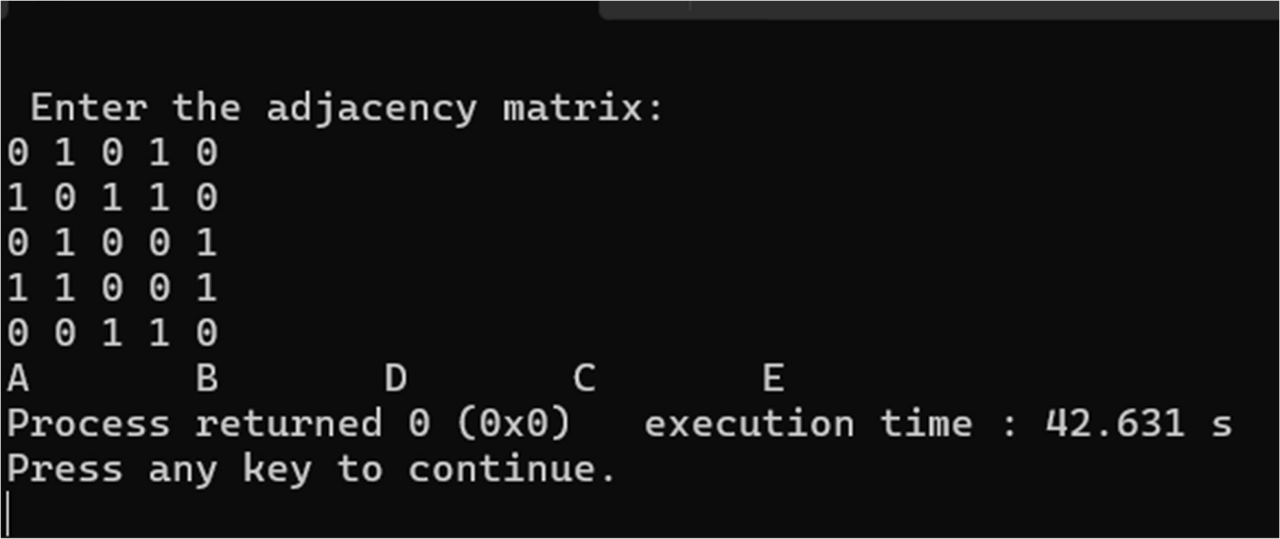

1. **Write a program to check whether a given graph is connected or not using the DFS method.**

#include <stdbool.h> #include <stdio.h> #include <string.h> #define N 50

int gr[N][N]; bool vis[N];

void Add_edge(int u, int v){ gr[u][v] = 1;}

void dfs(int x){ vis[x] = true;

for (int i = 1; i <= N; i++) if (gr[x][i] && !vis[i])

dfs(i);}

bool Is_Connected(int n){ memset(vis, false, sizeof vis); dfs(1);

for (int i = 1; i <= n; i++){ if (!vis[i])

return false; }

return true;} int main(){

int n, u, v;

printf("Enter the number of vertices: "); scanf("%d", &n);

printf("Enter the number of edges: "); int m;

scanf("%d", &m);

printf("Enter the edges (u v):\n"); for (int i = 0; i < m; ++i) {

scanf("%d %d", &u, &v);

Add_edge(u, v); } if (Is_Connected(n))

printf("Connected\n"); else

printf("Not Connected\n"); return 0;

}

**OUTPUT:**

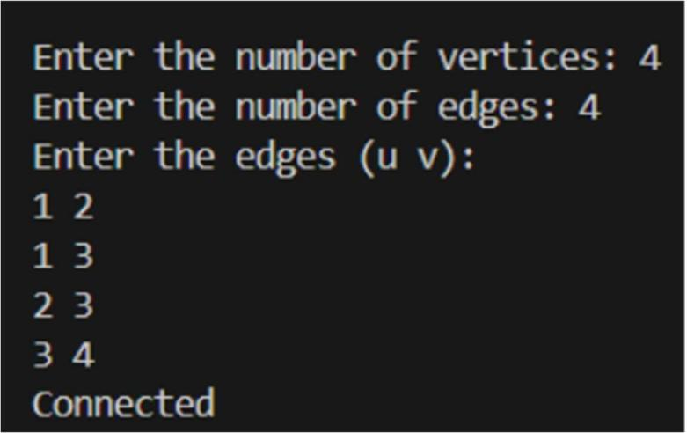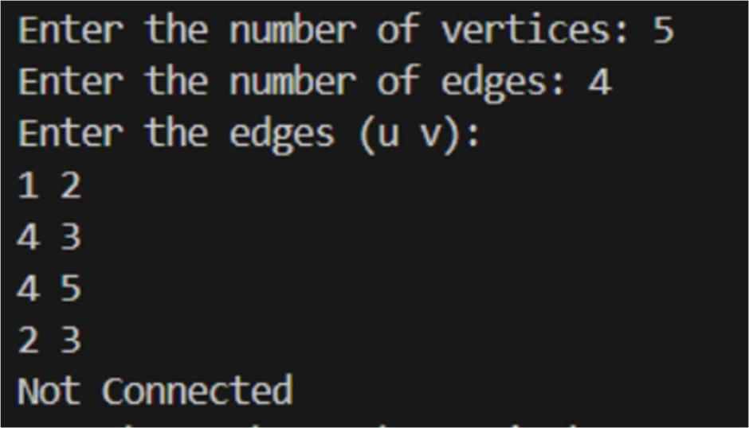

# LeetCode Programs:

* 1. Score of Parentheses(LP:856)

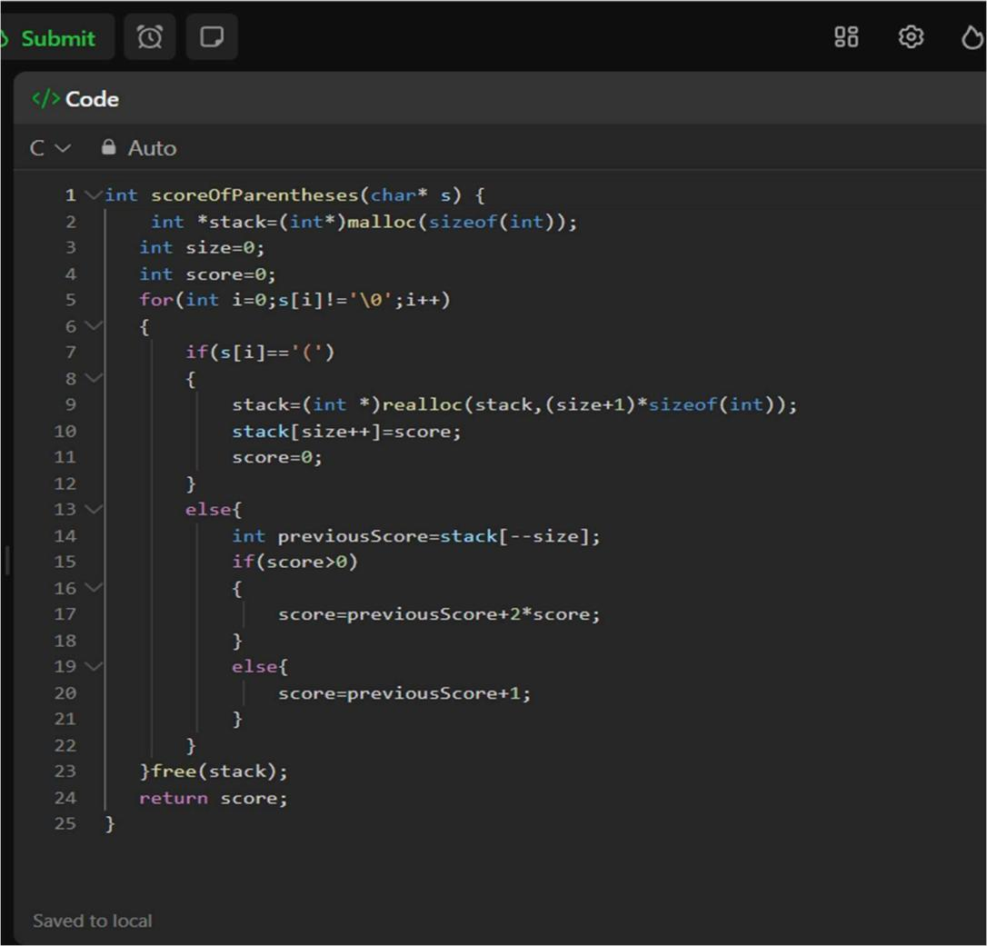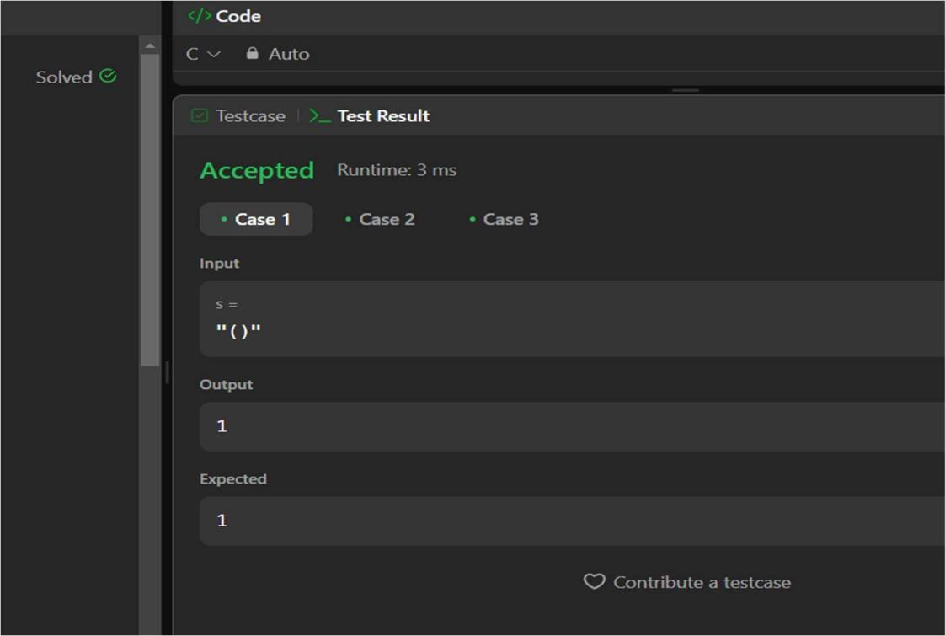

* 1. Odd Even Linked List(LP:328)

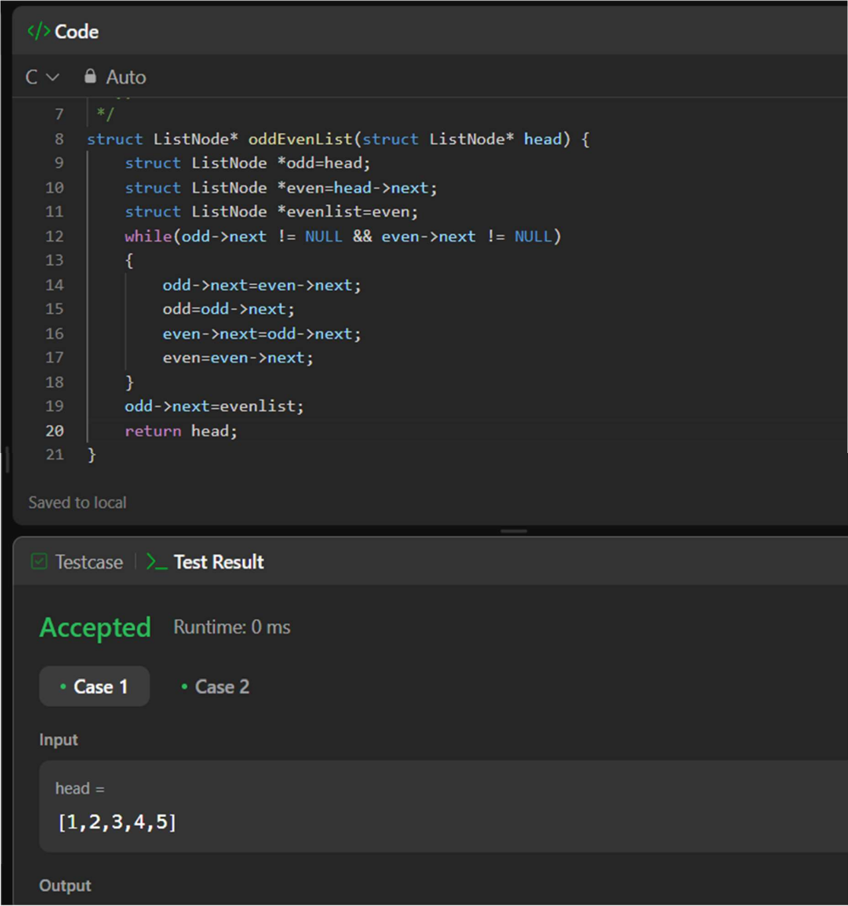

* 1. Delete middle node of linked list.(LP:2095)

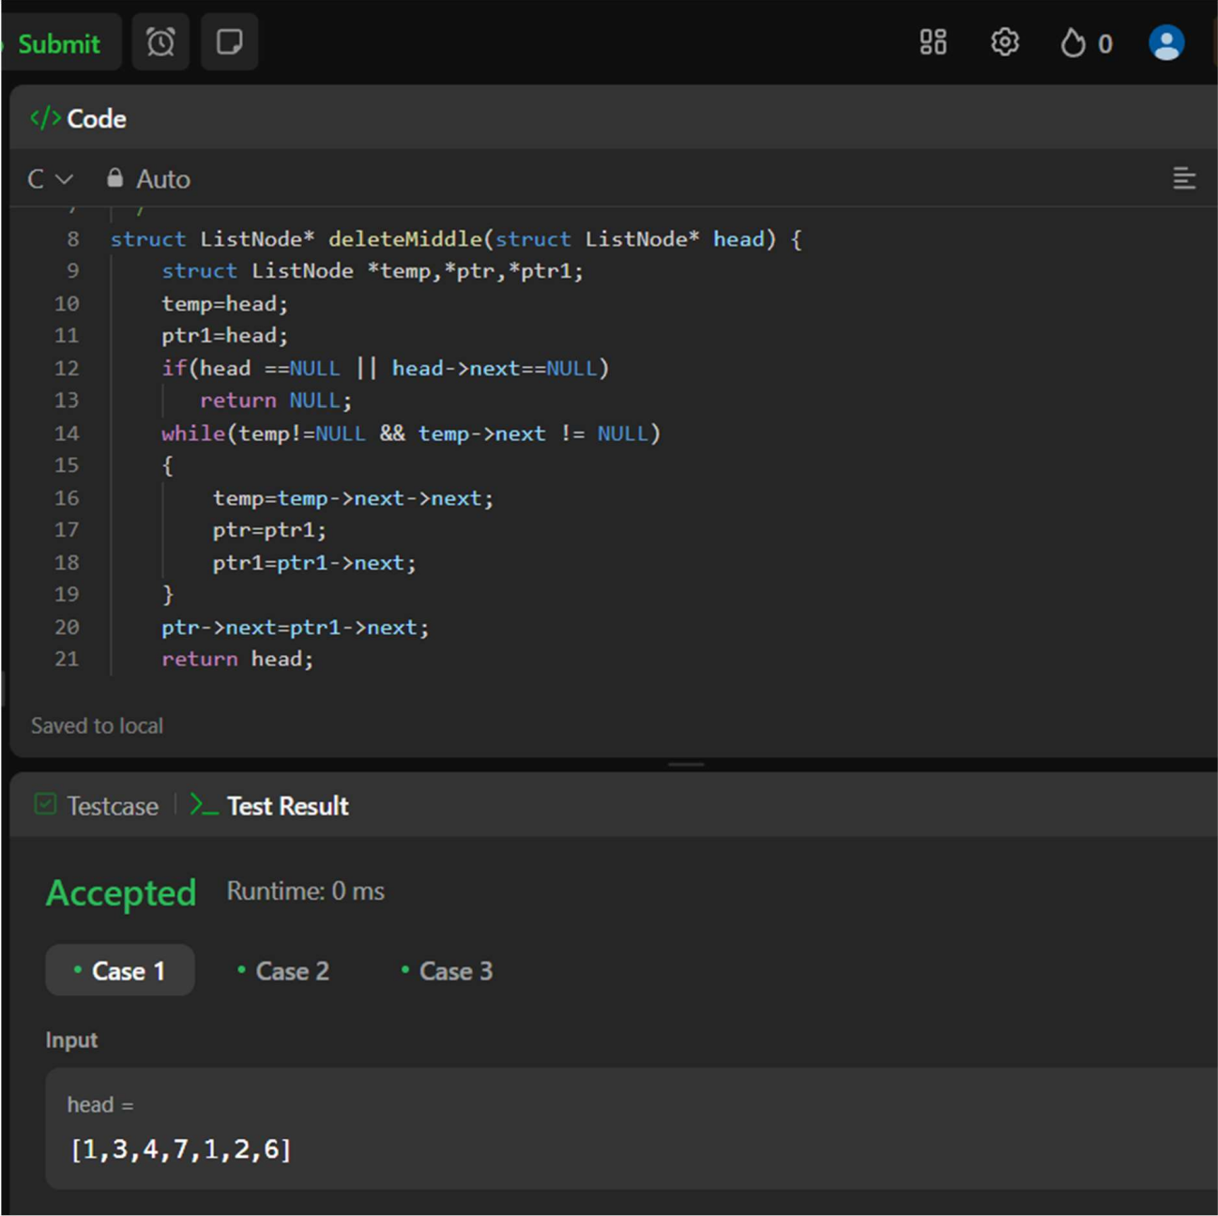

* 1. Delete a node in BST.(LP:450)

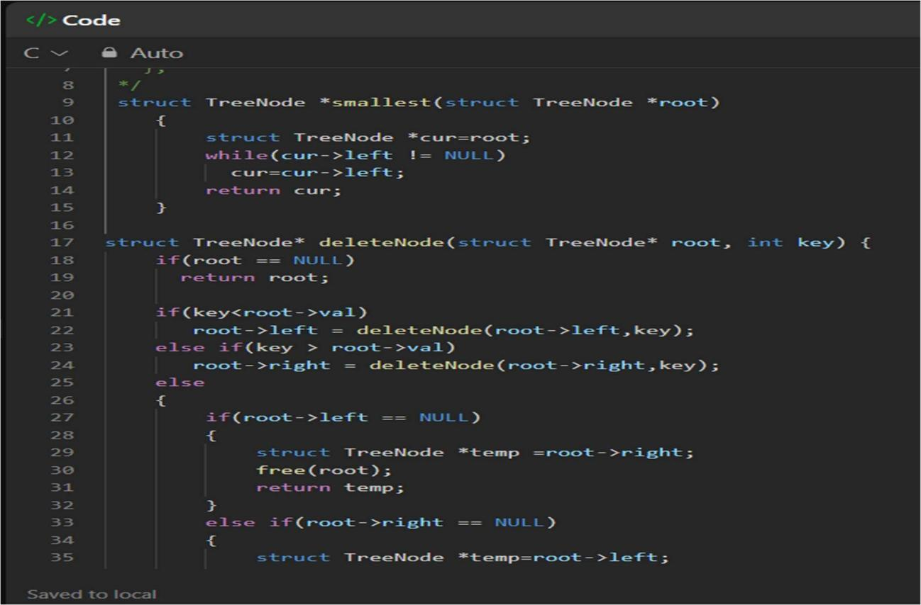

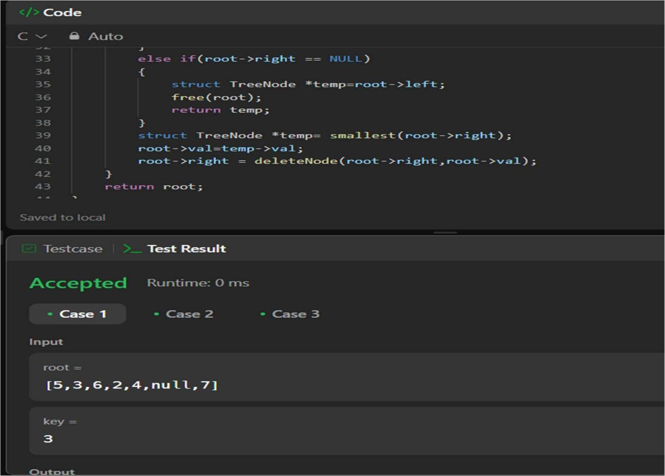

* 1. Bottom Left Tree Value.(LP:513)

